**MACROECONOMIC DETERMINANTS OF BANKS’ NON-PERFORMING LOANS IN NEPAL:**

**A VAR APPROACH**

**A Thesis**

**Submitted to the Department of Economics, Patan Multiple Campus,**

**Faculty of Humanities and Social Sciences, Tribhuvan University, Nepal,**

**in partial fulfillment of requirement of the Degree of**

**MASTER OF ARTS**

**In**

**ECONOMICS**

**By**

**PRAYUSH MAN SHRESTHA**

**Campus Roll No: 05/074**

**T.U. Regd. No: 6-3-22-1393-2017**

**Patan Multiple Campus, Patandhoka**

**Lalitpur, Nepal**

**December, 2021**

# 

# LETTER OF RECOMMENDATION

This thesis entitled **“MACROECONOMIC DETERMINANTS OF BANKS’ NON-PERFORMING LOANS IN NEPAL: A VAR APPROACH”** has been prepared by Mr. PRAYUSH MAN SHRESTHA under my guidance and supervision. I, hereby, recommend it in partial fulfillment of the requirements for the Degree of MASTER OF ARTS in ECONOMICS for final examination.

…………………………

Mr. Pujan Adhikari

Assistant Professor

Department of Economics, Patan Multiple Campus

Date: December, 2021

# 

# LETTER OF APPROVAL

We certify that this thesis entitled **“MACROECONOMIC DETERMINANTS OF BANKS’ NON-PERFORMING LOANS IN NEPAL: A VAR APPROACH”** submitted by PRAYUSH MAN SHRESTHA to the Department of Economics, Faculty of Humanities and Social Sciences, Patan Multiple Campus, Tribhuvan University, in partial fulfillment of the requirements for the Degree of MASTER OF ARTS in ECONOMICS has been found satisfactory in scope and quality. Therefore, we accept this thesis as a part of the said degree.

**Thesis Committee**

…………………………….

Prof. Dr. Bishnu Prasad Sharma

Head, Department of Economics,

Patan Multiple Campus

……………………………

Prof. Dr. Shiva Raj Adhikari

External Examiner

…………………………….

Pujan Adhikari

Thesis Supervisor

Date: December, 2021

# DECLARATION

I hereby declare that the thesis entitled, **“MACROECONOMIC DETERMINANTS OF BANKS’ NON-PERFORMING LOANS IN NEPAL: A VAR APPROACH”** submitted to the Department of Economics, Patan Multiple Campus, is entirely my original work prepared under the guidance and supervision of Pujan Adhikari, Assistant professor, Department of Economics, Patan Multiple Campus. I have made due acknowledgements to all ideas and information borrowed from different sources in the course of writing this thesis. The result of this thesis have not been presented or submitted anywhere else for award of any degree or for any other purpose. No part of the contents of this thesis have ever been published in any form before. I shall be solely responsible if any evidence is found against my declaration.

………………………

Prayush Man Shrestha

Department of Economics

Patan Multiple Campus, Patandhoka

T.U. Regd. No.: 6-3-22-1393-2017

Campus Roll No.: 05/074

# ACKNOWLEDGEMENTS

Not surprisingly, I owe many people a great deal in helping me write this thesis. They have changed my life substantially. I have learned a lot from them and feel very lucky to have met and worked with them. Whatever is admirable in this thesis is as much theirs as is mine.

First and foremost, I am deeply indebted to Pujan Adhikari for his constant guidance, support and advice. His enthusiastic passion for research, his intellectual openness and his willingness to lay down sophisticated theories in a simple way have been an invaluable example throughout my Graduate experience. As a supervisor, his advice on some fundamental principles about economic research will stay with me forever. I cannot thank him enough for his generosity with his time even at a difficult situation of pandemic.

Parts of this thesis owe much to discussion with other people. I have benefited from comments, discussion or general advice from many other member of the professions, among which I list: Bishnu Sharma, Pawan Singh, Raghu Bir Bista, Sabitri Shrestha, Ananta Raj Dahal, Prayen Shrestha, Ashim Amatya, Aashra Amatya, Shirisha Shrestha, Saujan Sainju, Akshit Shrestha, Bipul Maharjan, and others.

My friends were of great support throughout these years – without them, this thesis would not be completed. Dipesh, Sanish, Suruchi, and Mamta were miles away but yet so close. Neeti, Prativa, Prashansha, Sujat, Sarweshwor, Nima, Aman, Sanju, Sarita, Bina, Prajjwol all gave me more I could ever recompense. My colleagues and friends at PRI and IIDS, Abyaya, Binisha, Sanjeev, Bishu, Sagar, Om, Radhika and Yasub have proven so patient with my ideas, which they often times understood better than I ever did.

Finally, none of my accomplishment would have been possible without the love and support of my family. My mother, Urmila Pradhan, has been by my side through the travail of life. She has suffered and brought much joy, to her I am always indebted. I dedicate this thesis to my father.

December 2021 Prayush Man Shrestha

# ABSTRACT

Asset quality is an essential part of sound financial institution. On contrary, asset quality is difficult for banking regulators and investors to assess what factor might have affected it. This study identified that macroeconomic factors and bank specific factors are the main source of systematic risk that translates in the growth or decline of loan quality. There are two major objective of this study, first to analyze the trend and structure of the NPLs with other different macroeconomic variables. Secondly, to examine the macroeconomic determinants on NPL in the context of the Nepalese economy.

This study aims to fill the gap in the literature by providing empirical evidence on, nonperforming loans by using vector autoregression method to show the dynamic relationship in context of Nepal by considering macroeconomic variable money supply and others. This study examines the macroeconomic determinant of NPLs in Nepal covering the period of 2006:Q1 to 2020:Q4. The study compares impulse responses to high-frequency macroeconomic variables with NPLs, and summarize descriptive analysis, causality test, co-integration test and diagnostic test. The study found that when there is a positive shock in RGDP the weightage of banks' NPLs declines in the short run. Likewise, when there is a positive shock in interbank transaction rate, interest rate, and broad money supply the NPLs tend to decrease meanwhile, suggesting the bank-specific variable can be controlled by commercial banks.

Based on the findings of this study it can be concluded that macroeconomic factors plays a crucial role while determining the asset quality. The result of the test have justified the hypothesis of the study where the NPL is negatively correlated with interest rate, real gross domestic product and interbank transaction rate. Thus it suggests that the shock in NPLs is adversely affected by the macroeconomic variables such as the pace of economic activities, supply of money, volatile interest rate and interbank transaction rate.

**TABLE OF CONTENTS**

LETTER OF RECOMMENDATION ii

LETTER OF APPROVAL iii

DECLARATION iv

ACKNOWLEDGEMENTS v

ABSTRACT vi

LIST OF TABLE x

LIST OF FIGURE xi

ACRONYMS/ABBREVIATIONS xii

CHAPTER I: INTRODUCTION 1

1.1 Background of the study 1

1.2 Statement of the problem 3

1.3 Research Questions 3

1.4 Objectives 3

1.5 Hypothesis 4

1.6 Significance of the Study 4

1.7 Limitation of the Study 5

1.8 Organization of the Study 5

CHAPTER II: REVIEW OF LITERATURE 6

2.1 Introduction 6

2.2 Review of literature 6

2.3 Identification of research gap 9

CHAPTER III: RESEARCH METHODOLOGY 11

3.1 Introduction 11

3.2 Research Design 11

3.3 Conceptual Framework 12

3.4 Sources of data 13

3.5 Sample size and Sampling procedure 13

3.6 Method and Instrument of data collection 13

3.7 Data Management 13

3.8 Identification/Specification of model 14

3.9 Specification of variables and its Measurement 15

3.10 Technique of data analysis 16

3.10.1 Unit root testing 16

3.10.2 Selection of optimal lag 17

3.10.3 Co-integration test 17

3.10.4 Causality test 17

3.10.5 Impulse response 18

CHAPTER IV: DATA ANALYSIS 19

4.1 Introduction 19

4.2 Background to the Generation of NPLs 19

4.2.1 Current Situation of the NPL Problem 19

4.2.2 NPL Problem & Structural Changes 22

4.3 Trend and Structure 23

4.3.1 Trend and Structure of NPLs 23

4.3.2 Trend and Structure of RGDP 25

4.3.3 Trend and Structure of M2 27

4.3.4 Trend and Structure of IR 29

4.3.5 Trend and Structure of IBR 31

4.4 Empirical Analysis and Result 33

4.4.1 Descriptive Analysis and Correlation Matrix 33

4.4.2 Unit Root Test 34

4.4.3 Selection of Optimal Lag 37

4.4.4 Co-integration Test 38

4.4.5 Granger Causality Test 39

4.4.6 Serial Correlation Test 39

4.4.7 Impulse Response Function 41

4.5 Discussion 43

CHAPTER V: SUMMARY AND CONCLUSIONS 44

5.1 Introduction 44

5.2 Summary 44

5.3 Conclusion 45

REFERENCES 47

APPENDIX 52

# LIST OF TABLE

**Table No.** **Page No.**

**Table 1:** Indicator of financial position of commercial banks in 2020 1

**Table 2:** Empirical Studies after which the VAR is modeled 10

**Table 3:** List of variable and data sources 13

**Table 4:** List of variables and its measurement 16

**Table 5:** Loan classification as per NRB Directive 20

**Table 6:** Summary Statistics and correlations, 2006 Q1-2020Q4 33

**Table 7:** Unit root test results 35

**Table 8:** Selection of optimal lag length 37

**Table 9:** Unrestricted Cointegration Rank Test (Trace) 38

**Table 10:** Unrestricted Cointegration Rank Test (Maximum Eigenvalue) 38

**Table 11:** Granger causality tests for non-performing loans 39

**Table 12:** Breusch-Godfrey Serial Correlation LM test 40

# LIST OF FIGURE

**Figure No.**  **Page No.**

**Figure 1:** Determinants of non-performing loans of banks in Nepal 12

**Figure 2:** Non-performing loans of all the 27 commercial banks on mid-April 2021 21

**Figure 3:** Trend of Non-Performing Loans from 2006 Q1 to 2020 Q4 24

**Figure 4:** Trend of RGDP and NPLs from 2006 Q1 to 2020 Q4 26

**Figure 5:** Trend of Money Supply from 2006 Q1 to 2020 Q4 28

**Figure 6:** Trend of Interest Rate from 2006 Q1 to 2020 Q4 30

**Figure 7:** Trend of Interbank Transaction Rate from 2006 Q1 to 2020 Q4 32

**Figure 8:** Stationary level 36

**Figure 9:** Impulse response of banks’ NPL to macroeconomic variables in Nepal 41

# ACRONYMS/ABBREVIATIONS

ADBL : Agriculture Development Bank

ADF : Augmented-Dickey Fuller

AIC : Akaike Info Criterion

ARDL : Autoregressive Distributed Lag

BOKL : Bank of Kathmandu Limited

CAR : Capital Adequacy Ratio

COVID-19 : Corona Virus Disease 2019

CPI : Consumer Price Index

CZBIL : Citizens Bank Limited

EBL : Everest Bank Limited

EU : European Union

ERS : Elliot-Rothenberg-Stock

FDI : Foreign Direct Investment

FSRP : Financial Sector Restructuring Project

FSTAP : Financial Sector Technical Assistance Project

GDP : Gross Domestic Product

GVAR : Global Vector Autoregression

HC : Hannan and Quinn

IR : Interest Rate

IBR : Interbank Transaction Rate

KPSS : Kwaitowski-Phillips-Schmidt-Shin

LLP : Loan loss provision

MoF : Ministry of Finance

MOSU : Money Supply

NBL : Nepal Bank Limited

NPL : Non-performing loan

NRB : Nepal Rastra Bank

OLS : Ordinary Least Square

PP : Philips Perron

PVAR : Panel Vector Autoregression

RBB : Rastra Banijya Bank

REER : Real Effective Exchange Rate

SIC : Schwartz Info Criterion

VAR : Vector Autoregression

VRS : Voluntary Retirement Scheme

# CHAPTER I: INTRODUCTION

## Background of the study

Non-performing loans are that type of loans which are underperforming and having outstanding interest for more than 90 days. Until about ten years ago, non-performing loan of commercial banks in Nepal was at its highest. Nepalese commercial banks were suffering from its low-quality assets due to unregulated lending practices. Reducing this trend of low-quality assets Nepal Rastra Bank has adopted different guidelines and policy measures to improve the lending practices and facilitate the work of a macro-stress testing model to prevent NPL to increase.

At most general level, a NPL is a loan where a borrower is not making repayments in accordance with a contractual obligation, Bholat et al (2016). The non-performing loans are used as an indicator for financial stability and particularly banking system stability (Prasanna, 2014). Bad lending affects the liquidity and profitability of banks resulting into an unstable financial system in a country. A key economic consequence of insufficient LLPs and the persistence of NPLs on bank balance sheets is the combined threat of a ‘capital crunch’ with a ‘credit crunch’ Bholat et al (2016). The following table shows the financial position of Nepalese commercial banks in FY2020.

**Table 1:** Indicator of financial position of commercial banks in 2020

|  |  |
| --- | --- |
| Total number of commercial banks | 27 |
| Ratio of total credit to total deposit (per cent) | 83.01 |
| Share of LLP in total loans (per cent) | 2.45 |
| Share of NPLs in total loans (per cent) | 1.81 |

*Source:* NRB, Banking & Financial Institution Monthly Statistics, 2020

The growth of an economy is based on how well its financial institution is performing with their lending behavior. Over the past ten years, we can see Nepalese commercial banks’ NPLs to their total lending has reduced and maintained at less than 5 per cent, on this same period we have witnessed the highest growth rate since early 90’s, showing a sound financial system. On the contrary, a rise in the ratio of NPLs to total gross loans suggests a bad state in the banking sector results, signaling trouble for bank’s management as well as the regulator (Badar & Javid, 2013).

The macroeconomic factor affects the anti-cyclical behavior of the NPLs. The general explanation is that higher real GDP growth usually translates into more income which improves the debt servicing capacity of borrowers. Conversely, when there is a slowdown in the economy the level of NPLs is likely to increase as unemployment rises and borrowers face greater difficulties to repay their debt (Salas & Saurina, 2002; Rajan & Dahl, 2003; Fofack, 2005; Jimenez & Saurina, 2005).

Beside the macroeconomic factor the NPLs are also affected by the bank level factors such as, Berger and DeYoung (1997), studies showed that the NPLs are affected by macoeconomic factors as well as bank specific, the cost efficiency, capital, loan portfolio, equity to assets ratio etc were among some bank specific factors which affect the NPLs. The low cost efficiency is a signal of poor management practices, which implies that a result of poor loan underwriting, monitoring and control.

When the problems are left unsolved, nonperforming loans can compound into financial crisis, the moment these loans exceed bank capital in a relatively large number of banks (Fofack, 2005). Despite the implications of nonperforming loans for investment and economic growth, and for anticipating future banking and financial crises, the leading cause of these loans remains unknown for Nepal.

Currently, to determine how the banks’ non-performing loans respond to macroeconomic factors several studies showed that Vector Autoregression (VAR)[1] method is most appropriate among others. This study investigates the macroeconomic factors that affect the nonperforming loans in Nepal.

## Statement of the problem

Non-performing loan has been the major problem of every financial institution, the increasing deposit creates more liquidity on a bank such that they try to provide loans as much as they can and in the process some loan might get into wrong hands who wouldn’t be able to repay its interest and principle. There has been rigorous research on how someone couldn’t repay their interest by considering bank-specific factors as well as macroeconomic determinants. Existing studies have shown that macroeconomic variables are the main source of systematic risk that translates in the growth or decline of loan quality (Schinasi, 2005; Festic, 2011).

If we look upon the recent trend of NPL it seems to be quite stable but when there is a shock in economy or with any macroeconomic or bank specific variable the quality of asset reduce significantly. Some macroeconomic variables such as real gross domestic product, money supply, unemployment rate, inflation rate, interest rate and interbank transaction rate have affected NPL significantly. For instance, when the economy was hit by COVID the proportion of NPL were increased as such when the inflation rate increases the real weightage of NPL would affect instantly. This sort of variables has been creating an issue to increase of NPL in the financial institutions, furthermore, it is require to understand the determinant of the NPL considering different factors.

## Research Questions

The purpose of this thesis is to empirically answer the following questions:

1. What are the major macro factors that determine the NPL of a commercial bank?
2. Does volatile interest rate influence the commercial banks’ NPL?
3. How does the broad money supply affect the size of the NPL?
4. Does interbank transaction rate affects NPL?

## Objectives

The major objective of this study is to find the major macroeconomic determinants which affect the non-performing loans, beside this fundamental objective there are also several objectives that this study tends to answer and they are:

1. To analyze the trend and structure of the NPLs with other different macroeconomic variables.
2. To identify the macroeconomic determinants of NPL in the context of the Nepalese market.

## Hypothesis

Based on the extensive literature review and research questions the following hypothesis are formulated:

1. H0: Interest rate has a positive relationship with NPLs.

H1: Interest rate has a negative relationship with NPLs.

1. H0: The growth in Real GDP will result in a fall of NPLs.

H1: The growth in Real GDP will result in an increase of NPLs.

1. H0: Money supply has a negative relationship with NPLs.

H1: Money supply has a positive relationship with NPLs.

1. H0: Rising interbank transaction rate increase the NPLs.

H1: Rising interbank transaction rate decreases the NPLs.

## Significance of the Study

The study of NPL is more significant in the context of Nepalese commercial bank as it is an issue for the economy and the financial sector itself. Some studies like the one conducted by (Khemraj & Pasha , 2009) have considered macroeconomic variables like GDP, broad money supply, real effective exchange rate, inflation rate, etc. with some bank-specific variables such as the size of the institution, profit margins, and risk profile of banks, where they found that macroeconomic variables have significant relation with NPLs of commercial banks. However, bank-specific variables such as the size of the institution, and banks with aggression in the credit market showed no significant relationship. In the Nepalese context, there have been very few research on this topic by using simultaneous difference equations. So, to determine the macroeconomic variables of non-performing loans in Nepalese commercial banks this thesis has been prepared.

Thus this study will be helpful to bankers as well as aspiring researchers and student who want to explore more about the current situation of the non-performing loans of banks. To my knowledge, this paper will be the first to use the VAR method to study the macroeconomic determinant of NPLs. Thus, this will also contribute to the literature to provide insightful macroeconomic effects on NPLs which might be helpful to concerned authorities regarding policy formulation and implementation, and would also assist young researchers, academics, and scholars, etc.

## Limitation of the Study

This thesis primarily focuses to uncover the key macroeconomic determinant of commercial banks' NPLs including interbank transaction rate in the absence of bank-specific variables. Thus, this thesis is not able to show how employment rate and bank-specific variables such as return on asset, return on equity, loans to deposit ratio, size of the bank, etc. affecting the NPLs. An answer to this question would require more data and due to the unavailability of data’s some variables are left out.

## Organization of the Study

The structure of this thesis is as follows: the first chapter gives the general introduction of the study where the general background, objective, and limitation of the study have been expressed. The next chapter includes a literature review on macroeconomic factors with its existing empirical literature on NPLs. The third chapter research methodology shows the details about data management and the appropriate method for this thesis. The analysis and the interpretation of the result is presented in chapter four and it is followed by the last chapter summary, major findings, and recommendations.

# CHAPTER II: REVIEW OF LITERATURE

## Introduction

This chapter includes a review of literature on the macroeconomic determinant of banks’ NPLs. There have been numerous literary work on this topic and confirmed macroeconomic variables plays a crucial role to determine the credit risk. In this regard, many researchers have found that macroeconomic variables' effect on NPLs has distinguished result than that of bank-specific factors. Thus, this section helps to understand and bring insight to the research questions and will be the guideline for the entire upcoming sections.

## Review of literature

Over the past few years, the research on non-performing loans has expanded extensively, particularly considering the macroeconomic variables. Studies have shown that macroeconomic variables like GDP, interest rate, consumer price inflation, exchange rate, and money supply have more impacts on NPLs of commercial banks. Therefore, it is important to review the literature on the macroeconomic factors which have more effect on NPLs.

Theoretically, the relationship between loan quality and macroeconomic variables has been widely discussed by connecting the boom and depression of business cycles with the financial vulnerability and stability of the banking sector. It is observed that during boom growth in bank loans occurs with rapid rate and declines during the depression (Ahmad & Bashir, 2013).

Hasan (2019) empirically studies the the macroeconomic factors determining the non-performing loans of banking institution in Bangladesh using a time series data from 2000 to 2017. The study employed ARDL method to disover the significant relationships between the variables. The study concluded that GDP growth rate and inflation rate have no significant impact on the level of NPLs in Bangladesh.

Roman and Bilan (2015) empirically evaluate the effects of macroeconomic factors on non-performing bank loans in EU countries, for the period 200 to 2013. The result of this study showed that, GDP growth, unemployment and domestic bank credit are the major determinant of NPLs and also confirm that the quality of public finances is decisive for ensuring the financial soundness of bank.

In 2014, Prasanna investigated the determinants of non-performing loans in the Indian banking system by applying panel data modelling approach. Panel dataset of 31 Indian banks with yearly data that spans the period 2000 to 2012 totalling 372 firm years has been analysed. The study found that higher growth rate in savings and GDP is negatively associated with NPLs in Indian banks . On the other hand, higher interest and inflation rates contribute positively to rising non-performing loans.

Similarly, Sidemark (2014) incorporates GVAR[2] method to show that banks’ nonperforming loans are globally interlinked covering the period of Q1 2000 to Q3 2013. The study found that European banks’ non-performing loans are sensitive to shocks in real activity coming from the US, especially those countries with a dominant financial sectors.

Ahmad & Bashir (2013) used time series data for nine macroeconomic variables (annual growth in GDP, unemployment rates, real interest rate, inflation, the CPI, the real effective exchange rates, exports, industrial production and FDI) by using OLS technique, over the period of 1990 to 2011. The result show that GDP growth, interest rates, inflation rates, the CPI, exports and industrial production are significant in explaining NPLs, while unemployment, the REER and FDI are insignificant in explaining variations in NPLs.

Badar & Javid (2013) assessed the long and short run dynamics between non-performing loans and macroeconomic variables for the period January 2002 to December 2011 of commercial banks in Pakistan. The analysis ws conducted by employing co-integration, Granger causality and vector error correction models. The variables included in the model were inflation, exchange rate, interest rate, gross domestic product, and money supply. A long run relationship is found amon variables by employing Johansen and Juselius mutivariate cointegration. While pair wise bivariate co-integration reveals pair wise long run relationship between non-performing loans with money supply and interest rates. Granger causality test reveals inflation and exchange rate Granger caused non-performing loans. The short run dynamics of the vector error correction model shows a weak short run relationship exist between non-performing lonas with inflation and exchange rate. Hence, macroeconomic indicators are the sizeable determinants of non-performing loans.

Siraj & Sudarsanan (2013) investigated the performance of Indian commercial banks from 1999 to 2011 before and after the global financial crises by using ratios and absolute figures. The study urged nonperforming assets is a major threat in credit risk management of banks in India and stability of banks depends on the performance and quality of assets they hold.

Geletta (2012) explained the behavioral realtionship between NPLs and macroeconomic variables from two perspectives, demand and supply sides. On the demand side, during boom the investors anticipates the future returns. This futuristic optimism results in a relative higher demand for credit to invest in new projects. However, the demand for the credit falls as the investor are passive on the recessionary period. Secondly, on the supply side, it is all good for business as there is stable cash flow streams of the debtors and banks, timely repayment of loans, good credit score of borrowers, increase credit worthiness and willingness of banks for lending to borrowers.

Adebola, Yusoff, and Dahalan (2011) explored the determinants of non-performing loans covering the period 2007:1 to 2009:12. The study incorporates ARDL approach to examine the effects of macroeconomic variables which include industrial production index, interet rate and producer price index. Their study showed that, interest rate has a significant positive long run impact on NPLs of Islamic banking.

Babouček and Jančar (2005) empirically investigate using VAR method, defining set of macroeconomic variables (the real GDP growth rate, exports, imports, the rate of unemployment, inflation, interest rates, aggregate bank loans, the REER) on the development of the Czech economy and the functioning of its credit channel for the past 11 years. Their study shows that growth of GDP reduces the non-performing loans ratio, while rising unemployment and inflation leads to an increase in NPL ratio.

Hoggarth, Sorensen, & Zicchino (2005) uses a VAR approach to account for the dynamics between the fragility of the bamking system in the UK and adverse macroeconomic shocks. They account for the sector specific dynamics and find that both bank and corporate loan write-offs are specifically related to deviations in the output gap. They alos show that unexpected change in the nominal interest rate result in increased aggregate write-off ratio after one to three years.

Other empirical papers, such as (Espinoza & Prasad, 2010; Nkusu, 2011) use a PVAR to show that macroeconomic variables, in particular GDP growth are linked with falling NPLs. While (Espinoza & Prasad, 2010) show that rising interest rates have negative impact on the NPLs ratios, (Nkusu, 2011) confirm that higher unemployment and falling asset prices are associated with rising NPLs.

In Nepalese context, few empirical research has been conducted on macroeconomic determinant of NPLs. Bhattarai (2015) examine the impact of macroeconomic variables and bank specific variables on the non-performing loans of the commercial banks in Nepal covering the period of 2002 to 2012. The result showed that macroeconomic variables such as the real effective exchange rate have significant positive impact on NPLs.

The table 2 provides the detail of empirical studies after which the variable is selected and the VAR is modelled in the forthcoming chapter.

## Identification of research gap

This paper aims to fill the gap in the literature by providing empirical evidence on (1) nonperforming loans by using vector autoregression method in Nepal which will be the first to use this model to fill the gap and add empirical literature in context of Nepal. (2) While going through local literature most of them did not considered macroeconomic variable money supply, which this thesis will acknowledge and interpret its relevancy on NPLs. Many paper showed the relevancy of cross country methodology, whereas this thesis tends to identify the determinant of non-performing loans within-country context, by using the methodology incorporated by Klien (2013).

**Table 2:** Empirical Studies after which the VAR is modeled

|  |  |  |  |  |  |
| --- | --- | --- | --- | --- | --- |
| Empirical Study | Dimension | Lag order | Model | Frequency | Variables |
| Sims (1986) | 6 | 4 | VAR | Quarterly | Output, investment, price level, M1, unemployment rate, T-bill rate |
| Marcucci & Quagliariello (2006) | 9 | 2 | VAR | Quarterly | Output, default rate, capital, inflation rate, output gap, interbank interest rate, spread, REER, housing investment |
| Fofack (2005) | 5 | 2 | VAR | Yearly | REER, economic growth, net interest margin, interbank loans, and real interest rate |
| Bernanke & Gertler (1995) | 4 | 12 | VAR | Monthly | Output, price level, commodity prices, FedFunds rate |
| Shan (2005) | 7 | 4 | VAR | Quarterly | RGDP, investment, total credit, stock market index, CPI, Trade, interest rate |
| Kjosevski (2017) | 7 | 1 | VAR | Yearly | Growth, inflation, credit, equity, ROA, ROE, gross loan |
| Klein (2013) | 5 | 2 | VAR | Yearly | NPL, growth, unemployment rate, credit, inflation |
| Agiropoulos, Galanos, & Poufinas (2021) | 3 | 2 | VAR | Yearly | NPL, debt, CPI, tax income, unemployment |
| Ito & Sato (2008) | 5 | 8 | VAR | Monthly | Oil, exchange rate, output gap, money supply, prices |

# CHAPTER III: RESEARCH METHODOLOGY

## Introduction

Based on the above literature review, this section provides the roadmap for the upcoming sections. This study consider the macroeconomic variables where the data are readily available from the reliable secondary sources, as we will discuss them later in this chapter. In this context, this chapter is divided into different headings, starting from research design, building conceptual framework to specification of model and technique of data analysis, it will provide how the entire analysis will carry out.

## Research Design

This thesis is based upon the descriptive as well as analytical research design in order to meet the objective and to answer the questions that were built in first chapter. Both the research design is equally important for this study, as descriptive analysis helps to understand what had happened and what is happening, its emphasis is more on fact finding about non-performing loans in Nepal.

On the other hand, analytical research design is appropriate for this study since it attempt to discover cause and effect relationship and analyze the relationship between the macroeconomic variables. Perhaps it is necessary for this study to conduct through an analytical design such as to give the broader view of the research and it tends to answer how and what might be the major macroeconomic determinants by considering the variable weightage effect over its dependent variable which is NPLs.

Thus this study particularly based on two type of research design – descriptive and analytical research design. In descriptive research design, the study particularly focuses on the macroeconomic determinant of NPLs as such there are variation in the data and to identify the main model parameter it is necessary to use descriptive research design. Similarly, the analytical research design will enhance the model for further analyzing the effects of macroeconomic determinants on the non-performing loans.

## Conceptual Framework

The concept for this paper is based on the literature review where it can be clearly found that the non-performing loan of banks are affected by the macro-economic along with the bank specific factors. To determine what affects the non-performing loans of commercial bank in Nepal, the following charts has been created to understand the concept of the variables, how it has been generated and possible macroeconomic factors which needed to be considered for further analysis.

**Figure 1:** Determinants of non-performing loans of banks in Nepal

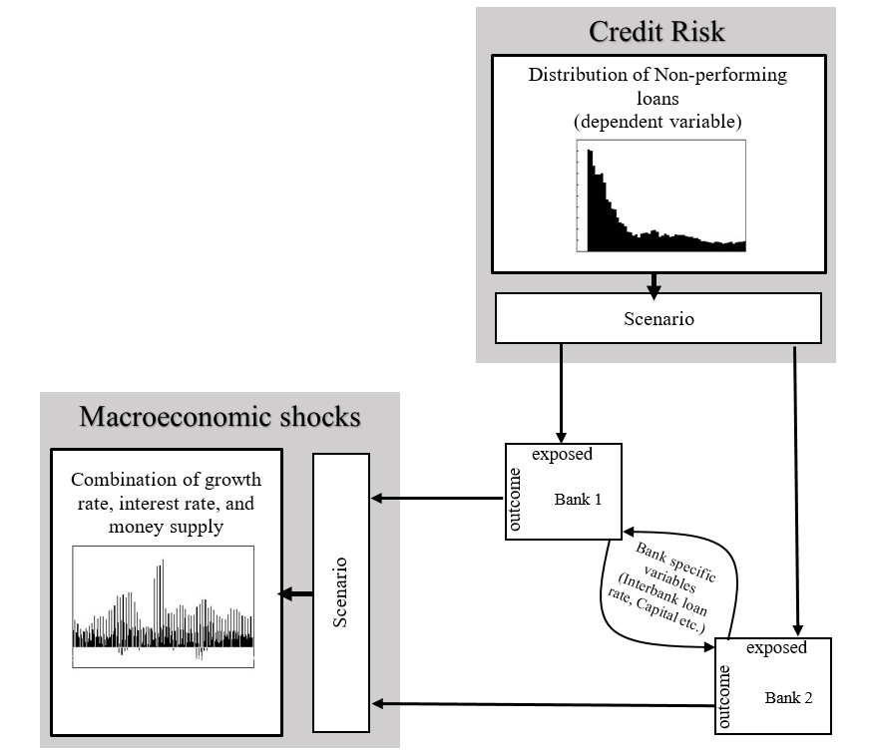

## Sources of data

This thesis is based on secondary data where the macroeconomic variables which has been considered here are readily available from the secondary sources. The summary of the variables and the data sources are listed below:

**Table 3:** List of variable and data sources

|  |  |
| --- | --- |
| **Variable Names** | **Data Source** |
| Non-performing loans | NRB, Key Financial Indicator (2020) |
| Gross Domestic Product growth rate | CBS (2020) |
| Interest Rate | Maskay & Pandit (2009), NRB (2020) |
| Money Supply | NRB, Quarterly Economic Bulletin |
| Interbank transaction rate | NRB, Quarterly Economic Bulletin |

## Sample size and Sampling procedure

The data used in this study is quarterly data from 2006 to 2020 which makes the total sample size of 60.

## Method and Instrument of data collection

Secondary data were collected through different sources as mentioned above. The method of secondary data were collected through different publications of Ministry of Finance, Central Bureau of Statistic and Nepal Rastra Bank. The data collected for this thesis is shown in appendix below.

## Data Management

The multivariate data is collected from commercial banks which have been operating since 2006 in Nepal. The model is based on the data from Q1 2006 to Q4 2020 with 60 observation. The dependent variable in this model is non-performing loans to total gross loans. The reliable sample of NPL ratio has been compiled from central bank of Nepal as mentioned above in data sources. Whereas, the explanatory variables are real GDP growth rate, interest rate, broad money supply growth rate and interbank transaction rate which are obtained from the central bank and supervisory authorities. The GDP and money supply are transformed into growth rate while NPLs, interbank transaction rate and interest rate are measured in percentage.

## Identification/Specification of model

A VAR is an n-equation, *n-*variable linear model in which each variable is in turn explained by its own lagged values, plus current and past values of the remaining *n-*1 variables. VARs are powerful tools for describing data and for generating reliable multivariate benchmark forecasts (Stock & Watson, 2001). The VAR model allows us to provide all the possibility of feedback between all our variables.

According to Sims, all variables appearing in the structural models could be argued to be endogenous. Economic theory place only weak restrictions on the reduced form coefficients and on which variables that should enter a reduced form model. Sims suggested that empirical research should use small-scale models identified via a small number of constraints (Bjørnland, 2000).

There are several advantages of VAR model and some of them are listed below:

1. It makes fewer restrictions which allows to develop the potential relationships between variables without no restriction of exogeneity i.e all variables are treated equally.
2. It is useful for describing the dynamic behavior of economic and financial time series.
3. Useful for forecasting which is better than other complex simultaneous difference model.

On the contrary, there are numerous challenges of this model such as:

1. Selection of appropriate lag length
2. It is difficult to interpret as it is conditional on many other coefficient
3. It gives more emphasis to forecasting which might not be suitable for policy analysis
4. VAR model uses less prior information and is more theoretical.

The standard form of VAR can be expressed in the following equation:

$y_{t}= α_{0}+ \sum_{i=1}^{n}{α_{i}}y_{t-i}+ε_{t}$ (1)

Where,

*yt = f (NPLt,GDPt,MOSUt,IRt,IBRt)*

α0 = *(n 1)* matrix coefficient of autonomous variables

αi = *(n $×$ n)* matrix coefficient of all the variables in the model

yt-1 = lagged values of *NPL,GDP, IR, MOSU* and *IBR*

εt = *(n $×$ 1)* stochastic disturbance term which is not correlated and is random

Incorporating all the variables in the equation 1 we can define the VAR equation. It can be postulate in the equation of VAR model for non-performing loan by incorporating all the variables, which can be written as:

NPLt = a10 + a11NPLt-1 + a12GDPt-1 + a13IRt-1 + a14MOSUt-1 + a15IBRt-1 +ε1t (2)

GDPt = a20 + a21NPLt-1 + a22GDPt-1 + a23IRt-1 + a24MOSUt-1 + a25IBRt-1 + ε2t (3)

IRt = a30 + a31NPLt-1 + a32GDPt-1 + a33IRt-1 + a34MOSUt-1 + a35IBRt-1 + ε3t (4)

MOSUt = a40 + a41NPLt-1 + a42GDPt-1 + a43IRt-1 + a44MOSUt-1 + a45IBRt-1 + ε4t (5)

IBRt = a50 + a51NPLt-1 + a52GDPt-1 + a53IRt-1 + a54MOSUt-1 + a55IBRt-1 + ε5t (6)

Now turning the above equations (2) to (6) into a matrix form we get:

$\left[\begin{aligned}\begin{aligned}{NPL}_{t} \\ {GDP}_{t} \\ {IR}_{t} \\ {MOSU}_{t}\end{aligned} \\ {IBR}_{t}\end{aligned}\right]=\left[\begin{aligned}a_{10} \\ a_{20} \\ a_{30} \\ a_{40} \\ a_{50}\end{aligned}\right] \left[\begin{matrix}a_{11} & a_{12} & a_{13} & a_{14} & a_{15} \\ a_{21} & a_{22} & a_{23} & a_{24} & a_{25} \\ a_{31} & a_{32} & a_{33} & a_{34} & a_{35} \\ a_{41} & a_{42} & a_{43} & a_{44} & a_{45} \\ a_{51} & a_{52} & a_{53} & a_{54} & a_{55}\end{matrix}\right] \left[\begin{aligned}{NPL}_{t-n} \\ {GDP}_{t-n} \\ {IR}_{t-n} \\ {MOSU}_{t-n} \\ {IBR}_{t-n}\end{aligned}\right]+\left[\begin{aligned}ε_{1t} \\ ε_{2t} \\ ε_{3t} \\ ε_{4t} \\ ε_{5t}\end{aligned}\right]$

Where,

αi = is a (5 $×$ 5) matrix of parameter that are non-zero

εt = is a (5 $×$ 1) column vector of stochastic disturbance term

## Specification of variables and its Measurement

This research paper particularly focuses on the determining factors of the non-performing loans in Nepal, such that dependent variable here would be non-performing loans itself. Therefore, it is measured by dividing the non-performing loans with total gross loans (percent). The macroeconomic shocks which affect the NPLs of commercial bank in Nepal are explained by three factors which are GDP, interest rate, money supply and interbank transaction rate. The variables which are selected for this study are listed below along with how it has been measured are summarized as follows:

**Table 4:** List of variables and its measurement

|  |  |  |
| --- | --- | --- |
| **Variable Names** | **Notation** | **Description** |
| Non-performing loans (percent) | NPLt | The ratio of non-performing loans to total gross lending |
| Gross Domestic Product growth rate | GDPt | The change in quarterly growth rate in real GDP at time t |
| Interest Rate (percent) | IRt | Quarterly nominal weighted average lending rate of bank at time t |
| Money Supply growth rate | MOSUt | The percentage change in quarterly Broad money supply at time t |
| Interbank Transaction Rate | IBRt | Quarterly weighted average interbank transaction rate at time t |

## Technique of data analysis

### Unit root testing

To estimate the model procedures for this thesis the VAR provided by (Sheefeni, 2015; Sidemark, 2014) have been used. The first step would be to use the unit root test. If the variable included in the analysis exhibit a trend over time it would be possible to interpret the time series are not stationary or contains unit root. When data contains unit root it means any result accrue to such data will be spurious or nonsensical (Sheefeni, 2015). In order to test such unit root there are several methods such as Augmented-Dickey Fuller Test (ADF), Pantula test, Phillips Peron tests, Kwaitowski-Phillips-Schmidt-Shin (KPSS), and Elliot-Rothenberg-stock point optimal (ERS). This study will use ADF and PP test for unit root.

### Selection of optimal lag

The second step in specifying a VAR is choosing the lag length for the right hand side variables. There are several approaches to specify lag length to choose the appropriate lag length. The optimal number of lag that must be included for this study is determined by Akaike Info Criterion (AIC), Schwartz Info Criterion (SIC), and Hannan and Quinn (HC).

### Co-integration test

In the third step is to test the co-integration. Because it provides one way to study equilibrium relationships, it is a cornerstone of current time series analysis. Co-integration says that two non-stationary variables maybe related in multiple ways. Specifically, it allows us to consider the possibility that two variables that are non-stationary can be related in the short term, while also exhibiting correlation over the long term (Steffensmeier, Freeman, Hitt, & Pevehouse, 2014). Thus in this study the number of co-integrating relationships for the individual VAR model are computed using the Johansen trace statistic as outlined by Sheefeni, (2015).

### Causality test

The fourth step would be to conduct causality test. Granger (1969) developed model based on lead and lag relations in forecasting. It assumes hypothesis can be tested within the F-test framework. Let us take an example of bivariate VAR model:

$Y_{t}= α_{0}+ \sum_{i=1}^{n}{α_{1i}}X_{t-i}+ \sum_{i=1}^{n}{α_{2i}}Y_{t-i}+ε_{1t}$ (7)

$X_{t}= β_{0}+ \sum_{i=1}^{n}{β_{1i}}X_{t-i}+\sum_{i=1}^{n}{β_{2i}}Y_{t-i}+ε_{2t}$ (8)

The Granger causality test is used to determine the variables relationship and seeks to answer questions such as

1. ‘Do changes in Yt cause change in Xt?
2. If Yt cause change in Xt, lags of Yt should be significant in the equation for Xt. If such we say that Yt “Granger-causes” Xt.
3. If Xt cause Yt, lags of Xt should be significant in the equation for Yt
4. If both sets of lags are significant, there is ‘bi-directional causality’

### Impulse response

VAR model are often difficult to interpret as such one solution for it is to construct the impulse responses as it shows the responsiveness of the dependent variables in the VAR to shocks to error term. Thus we can also examine how long and to what degree a shock to a given equation has on all of the variables in the system. This technique determines how much of the forecast error variance for any variable in a system, is explained by innovation to each explanatory variables, over a series of time horizons (Stock & Watson, 2001).

# CHAPTER IV: DATA ANALYSIS

## Introduction

This chapter provides insight to the situation of NPLs and its empirical analysis, which are based on the central bank dataset. The chapter is divided into three different sections – in section 4.1, the background to the generation of NPLs is discussed. Similarly, in section 4.2, the trend and structure of the variable considered for this study are discussed along with figures. Followed by the most important section 4.3, where empirical analysis is carried out through descriptive analysis, correlation test, serial correlation test, unit root test, selection of optimal lag, co-integration test, granger causality test and impulse response function.

## Background to the Generation of NPLs

This section gives a brief overview of the background to the current generation of NPLs in Nepal. To make it clear this section also discusses the current situation of the NPL along with the context of COVID-19. Similarly, the major problem of non-performing loans and how the structural change had changed these type of loans will be explained in the forthcoming sub-sections.

### Current Situation of the NPL Problem

Before getting into the non-performing loan problem it is equally important to understand what is considered as a non-performing loans and how the loans are classified different categories in Nepal. As mentioned in the first chapter of this study the non-performing loans are those loans which have outstanding interest for more than 90 days are considered as a NPLs. Sometimes when a obligor has two or more loans from the same credit institution and if the obligor falls behind repayment on one loan but is repaying on the other, there is debate about whether the performing loan should also be classified as NPL, since the delinquency on one loan implies that the obligor’s overall financial state has deteriorated (Bholat, Lastra, Markose, Miglionico, & Sen, 2016). According to the NRB unified directive 2077, the loans are classified based on weakness and dependence on collateral securities into five categories and prescribed the provisioning rate as follows:

**Table 5:** Loan classification as per NRB Directive

|  |  |  |
| --- | --- | --- |
| **Classification of Loans** | **Due duration** | **Loan loss Provision** |
| Standard/Pass/Good | Less than 3 months | 1% |
| Under Supervision | Up to 3 months | 5% |
| Sub Standard | 3 month to 6 month | 25% |
| Doubtful | 6 month to 1 year | 50% |
| Loss | More than 1 year | 100% |

*Source:* Nepal Rastra Bank, Directives for commercial banks, 2020

Such type of loans which have due over a year or so, had decreased significantly over the decade maintaining below 2%. Ever since the outbreak of virus the non-performing loans of banks have increased on each quarter because lots of people have lost their job, many transportation, hospitality and airlines entrepreneur were hit rock-bottom and suffered due to the immobile situation created by the COVID-19.

After the outbreak of corona virus and the government of Nepal imposed strict lockdown which create immobile situation in a country such that the non-performing loan of the commercial bank has increased significantly. The non-performing loans of commercial bank stood at 1.62 per cent on mid-january 2020, then it gradually increases and reached 1.81 per cent on mid-july 2020. After the government imposed with liberal lockdown rules the non-performing loans of commercial bank started to decline since mid-october 2020 and reached 1.40 per cent on mid-july 2021.

While going through the bank specific non-performing loans for the mid-april 2021, it can be clearly seen that the majority of the state-owned bank have highest non-performing loans in comparison to other private commercial banks. The private bank outperform the state owned bank on total capital fund, higher deposit, lower NPL rate, and higher base rate. The following figure gives us the visual clarity of all the 27 banks with its non-performing loans:

**Figure 2:** Non-performing loans of all the 27 commercial banks on mid-April 2021

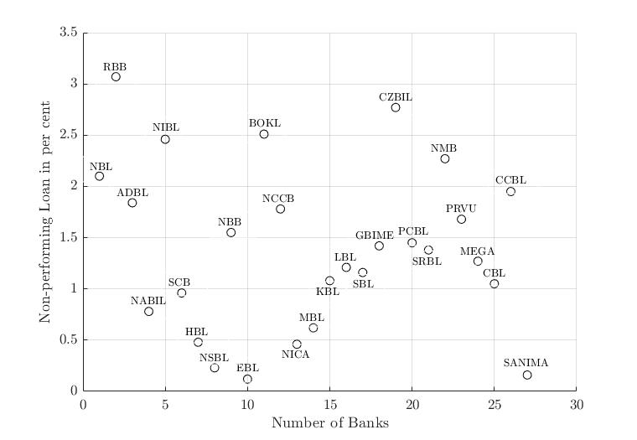

The above figure shows the non-performing loans of all the commercial banks where on x-axis there is number of banks and on y-axis non-performing loans in per cent. Among three state owned bank in Nepal, Rastra Banijya Bank (RBB) has highest NPL with more than 3 per cent which is also the highest among all the 27 commercial banks in Nepal. The Agriculture Development Bank (ADBL) has lowest NPL among the three state owned bank which stood at 1.8 per cent in mid-april 2021, but it is not the lowest among all the commercial bank in Nepal. Now talking about private commercial bank, Citizen Bank (CZBIL) has the highest NPL with 2.7 per cent followed by Bank of Kathmandu (BOKL) and Nepal Investment Bank (NIBL) at 2.5 per cent. The lowest NPL among all the 27 commercial bank was Everest Bank (EBL) which stood at 0.12 per cent in mid-april 2021. By going through figure 2 we can say that on an average the non-performing loans of the commercial bank stood at 1.41 per cent which justifies that Nepalese commercial bank are performing better than the year before.

### NPL Problem & Structural Changes

In 2003, the commercial banks’ aggregate capital adequacy ratio (CAR) of capital funds to risk weighed assets was -5.49%. The state owned banks were particularly performing poorly – the CAR of RBB, NBL and ADBL were all negative and technically insolvent. In the same year, the overall banking sector’s NPL ratio was 27%. The public banks’ NPL ratio were substantially higher than the banking sector average. At the state-owned banks, loan classification and provisioning were extremely lenient and loan overdue up to 5 years were classified as doubtful. In 2003, RBB and NBL reported net losses of Nrs4.8 billion and Nrs0.3 billion, respectively (Ozaki, 2014). Limited autonomy in the regulatory framework by NRB was also a problem.

Due to this huge amount of loss from the state owned bank, the World Bank FSTAP and FSRP supported the restructuring of state-owned commercial banks NBL and RBB. The external management team was included at RBB on 2002, where they conducted VRS programs, restructure the organization and staff size was reduce from over 5000 employees in 2002 to below 2600 employees by 2009. The number of bank branches were reduce from 200 to 123 during the same period, similarly computerize all the branches with 95% of deposit and 98% of loans were automated and online. In similar fashion, at NBL, staff size was reduced from 5652 to 2960, number of branches were reduce from 200 to 114, and IT system was implemented in 58 branches with 77% of deposit and 88% of loans were covered by the platform.

These financial reform activities brought positive change to RBB and NBL where they doubled the total assets in between 2003 to 2012. Their portfolio have improved significantly, with 60% of gross NPL ratio in 2003 to 7% in 2012 at RBB, and 60% to 6% at NBL. As a result, RBB and NBL’s total net worth declined from negative Nrs32 billion in 2003 to Nrs6 billion in 2012.

## Trend and Structure

Looking through 2006 to 2020, the trend and structure of dependent and independent variables are explicitly shown in this study. First, the non-performing loans trend will be discussed along with figure demonstrating how NPL have changed in each quarter starting from 2006 to 2020. In subsection 4.3.2 to 4.3.5, the independent variables such as RGDP, interest rate, and money supply rend will be discussed along with its figure.

### Trend and Structure of NPLs

With regard to the outlook of non-performing loans, it is tremendously on decreasing trend throughout the period – that is, through first quarter of 2006 to final quarter of 2020. As the impact of the COVID-19 has slowdown the economy such that its effect can be seen on NPL from the first quarter of 2020 which is slightly increasing.

As NPLs rise, so does the financial costs for commercial banks with bad loans on their books. These costs often are then passed onto firms and households, potentially slowing economic growth as credit contracts (European Bank Coordination Vienna Initiative, 2014). Due to COVID-19 such cost are transferred onto different firms, especially on hospitality and aviation industry in Nepal and households who often rely on day to day wages which ultimately discourage the borrowers from spending, reducing income and propensity to save.

The downward trend of NPLs started immediately after the restructuring of financial sector in 2006, but the sharp decline occurred a year later, when the restructuring in the financial sector expanded. Although more moderately, NPLs continued to decline since then, exhibiting strong and negative correlation with the pace of economic development.

Figure 3 presents data from the Nepal Rastra Bank on the ratio of non-performing loans to total gross lending in Nepal. The data nevertheless indicate the direction of travel, a growing convergence in NPLs among commercial banks that helps to explain the distinct feature of the Nepalese economy, its recent performance and the factors affecting it. The figure illustrates how the non-performing loans have changed over the time providing an inference about the Nepalese commercial banks’ experience on its lending practices.

**Figure 3:** Trend of Non-Performing Loans from 2006 Q1 to 2020 Q4

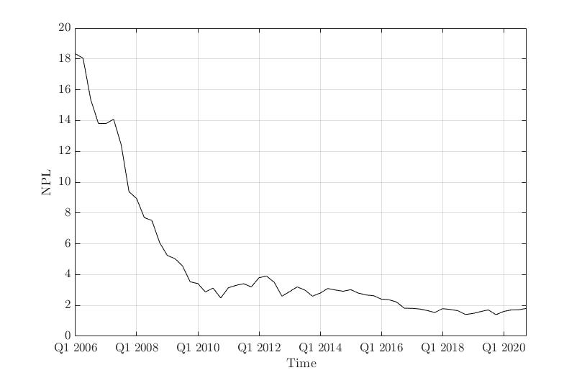

Initially, in 2006 Q1 to 2020 Q4, with Nepalese commercial banks having devoted about more than one quarter of their total loan portfolio to priority sector lending (peaking at about 41.18 per cent in 2020 Q4), the largest percentage of NPLs came from hospitality category of loans. The above figure shows the trend of NPLs, on the x-axis we have quarterly time duration and on y-axis represents the NPL rate of Nepalese commercial bank. From 2006 Q1 to 2010 Q4, the NPL decreases at a decreasing rate then later it starts to decrease at a stationary rate. Thus the NPL rate reached its minimum value on 2018 Q4 that is 1.4 per cent.

The NPLs rate from 2006 Q1 to 2020 Q4 is shown in Annex 1 where in each quarter it is in declining trend starting from 18.3 per cent in 2006 Q1, and reached 1.8 per cent by the end of 2020 Q4. This declining trend clearly shows that the financial cost of the commercial bank has significantly reduced over the decade with an increasing in the productivity, advancement in the development sector and effective and efficient use of financial resources.

### Trend and Structure of RGDP

With regard to the outlook of economic activity, there has been a fluctuating trend throughout the period – that is, through first quarter of 2006 to final quarter of 2020. Economics growth increases in the country remarkably, investment in industry, agriculture and service sector increases which leads to an increase in private sector credit. As the impact of the COVID-19 has slowdown the economy such that its effect can be seen on gross domestic product from the first quarter of 2020 it started to sharply decline.

Nepal’s economic growth has become negative by 2.12 per cent first time in the last two decade in FY 2019/20 due to the impact of COVID-19 pandemic, which has created more damage to the economy than the devastating earthquake of FY 2014/2015 (Ministry of Finance, 2020/21). The Nepalese economy is projected to have positive growth from the third quarter of the current fiscal year with the expectation of gradual improvement in the health crisis posed by second wave of the COVID-19.

As RGDP rise, so does the productivity of the commercial banks as their financial leverage gets minimized. The financial cost are often associated with the firms and household such that any exogenous shock in an economy may create potential slowing economic growth as credit contracts (Christiano, Motto , & Rostagno, 2010). On each decade the economy suffered by an exogenous shock, financial crisis on 2008, earthquake and blockade on late 2015, and COVID-19 from early 2020 has created chaos among people often losing billions of jobs, livelihood, and slowing down the economic activities.

Figure 4 presents data from the Central Bureau of Statistic (CBS) on the change in quarterly growth rate in real GDP in Nepal. The data nevertheless indicate the direction of travel, a fluctuation in RGDP over the period of time. The previous studies have shown that there is a negative relationship between NPL and GDP, the rising GDP often indicate that there is a lower NPL. If we look at figure 4 we can clearly see as the NPL declines the GDP starts to increase which clarify that there is a negative correlation between these variables. The figure illustrates how the real gross domestic product have changed over the time providing an inference about the Nepalese economy growth rate.

**Figure 4:** Trend of RGDP and NPLs from 2006 Q1 to 2020 Q4

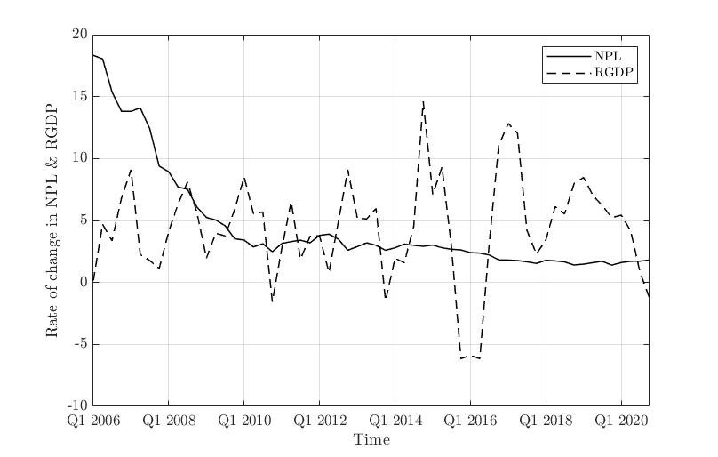

Initially, in 2006 Q1 to 2020 Q4, the Nepalese economic growth rate can be found fluctuating where there are 2 major downfall – one due to earthquake and the other due to corona virus pandemic. The above figure shows the trend of RGDP, on the x-axis we have quarterly time duration and y-axis represents the RGDP growth rate of Nepalese economy. From 2006 Q1 to 2020 Q4, throughout this period RGDP has been fluctuating with a major downfall can be seen on 2015 Q4 due to devastating earthquake and economic blockade made by India. Later the RGDP growth rate starts to get its momentum until 2019 Q3 then due to COVID-19 outbreak it started to fall.

The RGDP growth rate from 2006 Q1 to 2020 Q4 is shown in Annex 1 where in each quarter it is fluctuating starting from 0.8 per cent in 2006 Q1, and reached -1.28 per cent by the end of 2020 Q4. This fluctuating trend clearly shows that the financial cost of the commercial bank has significantly reduced over the decade with an increasing in the productivity, advancement in the development sector and effective and efficient use of financial resources.

### Trend and Structure of M2

The supply of broad money is determined by transactions between the banking sector and the non-bank private sector (non-banking companies and households) Butt et al (2012). In general, the transaction between the banking sector and non-banking private sector are involve in the creation and destruction of deposits and loans, which ultimately affect the supply of broad money. As the lending growth exceeds growth in broad money supply there are underlying weakness in lending, transforming it to NPLs.

With regard to the outlook of quarterly economic bulletin, the money supply has been increasing at a stationary rate throughout the period – that is, through first quarter of 2006 to final quarter of 2020. As the impact of the COVID-19 has slowdown the economy which affect both the movement of money and its velocity. Through the lens of Fishers equation, money supply is directly proportional to national income, with that caveat in mind, the money supply increases with an expectation of the positive growth in an economy. Thus from the first quarter of 2020 we can observe that supply of money increases.

As money supply increases, so does the financial resources of the commercial banks which helps to minimize their financial leverage. Broad money supply was weak from the onset of the global financial crisis in 2008 to the end of 2011, Butt et al (2012). The previous time the rate of money supply was so persistently low was in the early 2006. There has been improvement in areas of broad money supply, as in FY 2019/20, the ratio of broad money supply to GDP was 108.1 per cent, the ratio of debt flow to private sector to GDP was 83.7 per cent and total deposit to GDP ratio was 98.1 per cent (Ministry of Finance, 2020/21).

Figure 5 presents data from the Nepal Rastra Bank on the change in quarterly broad money supply in Nepal. The data nevertheless indicate the direction of travel, a short humped in between the period of time. The figure illustrates how the broad money supply have changed over the time providing an inference about the supply of money in an economy.

**Figure 5:** Trend of Money Supply from 2006 Q1 to 2020 Q4

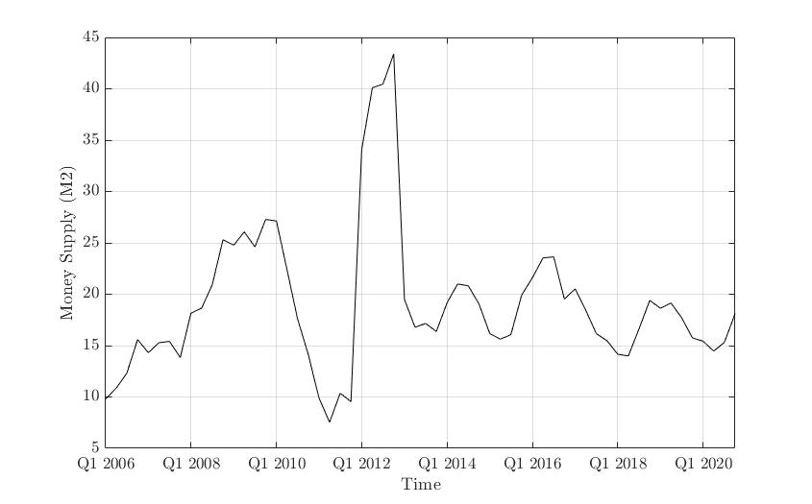

Initially, in 2006 Q1 to 2020 Q4, the Nepalese economic growth rate can be found fluctuating where there are 2 major downfall – one due to earthquake and the other due to corona virus pandemic. The above figure shows the trend of broad money supply, on the x-axis we have quarterly time duration and y-axis represents the rate of money supply in Nepalese economy. From 2006 Q1 to 2020 Q4, the broad money supply has been fluctuating with a major downfall can be seen on 2011 Q1. Although the size of the fluctuation changed after 2013 Q1 the velocity declined which indicates that we need to supply more to produce a unit of goods.

The broad money supply from 2006 Q1 to 2020 Q4 is shown in Annex 1 where in each quarter it is fluctuating starting from 9.8 per cent in 2006 Q1, and reached 18.1 per cent by the end of 2020 Q4. This fluctuating trend where the velocity of money is declining, clearly shows that the financial cost of the commercial bank has significantly reduced over the decade with an increasing in the cost of productivity, advancement in the development sector with an induced investment.

### Trend and Structure of IR

With regard to the outlook of quarterly economic bulletin, we can see that there has been a fluctuating trend of interest rate throughout the period – that is, through first quarter of 2006 to final quarter of 2020. As the impact of the COVID-19 has slowdown the economy such that its effect can be seen on lending Rate from the first quarter of 2020 it started to sharply decline. In this paper the quarterly nominal interest rate being used as the quarterly weighted average lending rate of bank.

The theory of interest rate says that the interest rate depend on risk, measured by its volatility, asymmetries as well as on average growth. The interest rate is also determined by how people value the future relative to today. The interest rate is typically high when the economy is performing well, and low when the economy does badly. The Ramsey framework helped in clarifying the way the interest rates are affected by the two components of trend growth (productivity growth and population growth) and in making clear the role of household preferences in affecting the interest rate (Rachel & Smith , 2015).

The interest rate effect can also be seen on the personal consumption which subsequently affect the GDP of an economy. As the economic theory indicates that effect of interest rates on personal consumption depends on the relative magnitudes of the substitution effect and the income effect. When the interest rate goes down, in other words, the magnitude of the substitution effect, which stimulates consumption, outweighs that of the income effect, which reduces interest income (Nakagawa & Oshima, 2000).

Figure 6 presents data from the Nepal Rastra Bank (NRB) on the change in quarterly weighted average lending rate of bank at time t. The data nevertheless indicate the direction of travel, a fluctuation in IR over the period of time. The volatility of interest rate is one of the major component of this study as such it is important to know how it has been changing over the period of time. Thus the below figure illustrates how the interest rate have changed over the time providing an inference about the Nepalese financial lending activities.

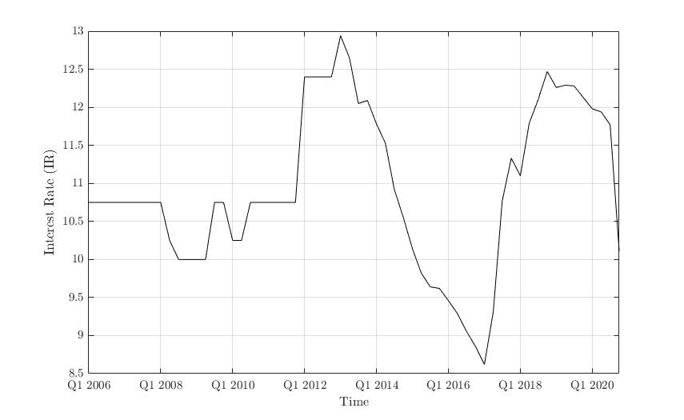**Figure 6:** Trend of Interest Rate from 2006 Q1 to 2020 Q4

Initially, in 2006 Q1 to 2020 Q4, the interest rate can be found fluctuating where there are 2 major downfall – one on early 2017 and the other on second quarter of 2020. The above figure shows the trend of interest rate, on the x-axis we have quarterly time duration and y-axis represents the IR of financial institution. From 2006 Q1 to 2020 Q4, throughout this period IR has been stable at initial period then it start fluctuating from 2008 Q1 with a major downfall can be observed on 2017 Q1 and 2020 Q2. The highest interest rate can be found at 13 per cent on 2013 Q1 having an increasing trend of output in this same period. Later the IR starts to get its momentum until 2019 Q1 then due to COVID-19 outbreak it started to fall again.

The IR from 2006 Q1 to 2020 Q4 is shown in Annex 1 where in each quarter it is in increasing trend starting from 10.75 per cent in 2006 Q1, and reached 10.11 per cent by the end of 2020 Q4. This fluctuating trend clearly shows that the financial cost of the commercial bank has significantly reduced over the decade with an increasing in the productivity, advancement in the development sector and effective and efficient use of financial resources showing sound financial system in the market.

### Trend and Structure of IBR

With regard to the outlook of quarterly economic bulletin, we can observe that there has been a fluctuating trend of interbank transaction rate throughout the period – that is, through first quarter of 2006 to final quarter of 2020. As the impact of the COVID-19 has slowdown the economy such that its effect can be seen on interbank rate from the first quarter of 2020 it started to sharply decline. In this paper the quarterly interbank transaction rate being used as the quarterly weighted average interbank transaction rate.

At most general level, the interbank rate is an interest rate at which bank borrow and lend their funds in the money market for short term. It is an overnight lending of one bank to another (Neupane, 2019). The accumulation of non-performing loans is generally attributable to a number of factors including economic downturns and macroeconomic volatility, high interest rate, overly high-priced interbank borrowings, insider lending and moral hazard. The interbank borrowings also have positive effect on moral hazard.

There is an unidirectional causality of interbank loans which suggests that the recourse to short-term financing at a high price might indeed have exacerbated the scope of banking crisis by contributing to a rapid accumulation of non-performing loans, through the moral hazard channel that extended the operations of problems banks, and hence, the cost of the crisis (Fofack, 2005). Generally, the coefficient associated with interbank loans has a positive sign, suggesting a positive covariance structure with nonperforming loans. These type of loans are generally executed at high and prohibitive rates, and these loans are build-up to meet short term liquidity at banks which may contribute to the rapid increase of impaired loans through its high price loans.

Figure 6 presents data from the Nepal Rastra Bank (NRB) on the change in quarterly weighted average interbank transaction rate of bank at time t. The data nevertheless indicate the direction of travel, a fluctuation in IBR over the period of time. The figure illustrates how the interbank transaction rate have changed over the time providing an inference about the Nepalese financial sector lending behavior.

**Figure 7:** Trend of Interbank Transaction Rate from 2006 Q1 to 2020 Q4

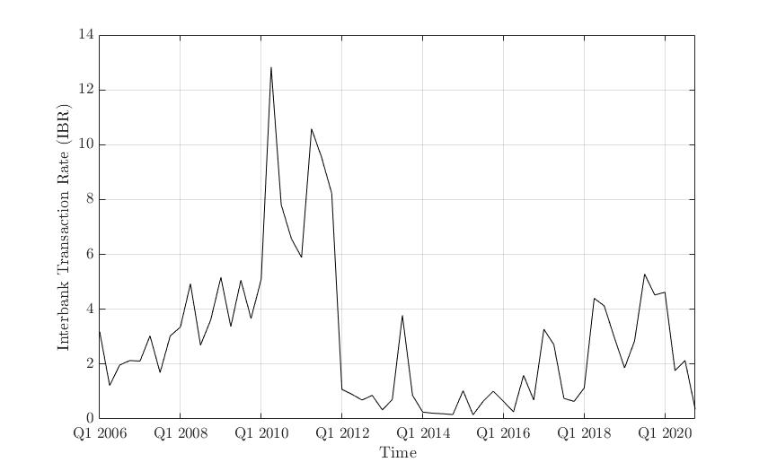

Initially, in 2006 Q1 to 2020 Q4, the interbank transaction rate can be found fluctuating where there is one major downfall – on early 2012. The above figure shows the trend line of interbank transaction rate, on the x-axis we have quarterly time duration and y-axis represents the IBR of financial institutions. From 2006 Q1 to 2020 Q4, throughout this period IBR has been increasing at a fluctuating rate then it starts declining at a fluctuating rate from 2010 Q2 with a major downfall can be observed on 2012 Q1 and 2020 Q1. The highest interbank transaction rate can be found at 13 per cent on 2010 Q2. Later the IBR starts to get its momentum until 2019 Q3 then due to COVID-19 outbreak it started to fall again.

The IBR from 2006 Q1 to 2020 Q4 is shown in Annex 1 where in each quarter its in increasing trend starting from 3.18 per cent in 2006 Q1, and reached 0.35 per cent by the end of 2020 Q4. This declining trend clearly shows that the financial cost of the commercial bank has significantly reduced over the decade with an increasing in the productivity, advancement in the development sector and effective and efficient use of financial resources showing sound financial system in the market.

## Empirical Analysis and Result

In this section we will unwrap the empirical analysis result with the help of summary statistic, followed by unit root, selection of optimal lag, autocorrelation test, co-integration, granger causality and impulse response.

### Descriptive Analysis and Correlation Matrix

The descriptive analysis is used to describe the nature of the selected variables throughout the study period. The descriptive analysis used in the study consist of mean, median, maximum values, minimum values, standard deviation, skewness, kurtosis, probability, sum square deviation and total number of observation. The below table shows the descriptive statistic of the variables:

**Table 6:** Summary Statistics and correlations, 2006 Q1-2020Q4

|  |  |  |  |  |  |
| --- | --- | --- | --- | --- | --- |
|  | **NPL** | **M2** | **IR** | **IBR** | **RGDP** |
| Mean | 4.5417 | 19.0853 | 10.9292 | 2.9350 | 4.3987 |
| Median | 2.9600 | 17.9155 | 10.7500 | 2.1300 | 4.6143 |
| Maximum | 18.3300 | 43.3882 | 12.9400 | 12.8300 | 14.6085 |
| Minimum | 1.4000 | 7.5296 | 8.6200 | 0.1500 | -6.1518 |
| Std. Dev. | 4.3017 | 7.0805 | 1.0558 | 2.7337 | 4.0982 |
| Skewness | 1.9377 | 1.5542 | -0.0440 | 1.5082 | -0.3219 |
| Kurtosis | 5.6617 | 6.0155 | 2.2212 | 5.3599 | 3.9360 |
| Jarque-Bera | 55.2572 | 46.8894 | 1.5356 | 36.6697 | 3.2263 |
| Probability | 0.0000 | 0.0000 | 0.4640 | 0.0000 | 0.1993 |
| Correlations  NPL | 1.0000 | * | * |  | * |
| M2 | -0.2340 | 1.0000 | * | * | * |
| IR | -0.1290 | 0.1371 | 1.0000 | * | * |
| IBR | -0.0343 | -0.2613 | -0.0656 | 1.0000 | * |
| RGDP | -0.0602 | 0.0566 | 0.0259 | 0.0898 | 1.0000 |

Table 6 reports the descriptive analysis of all the variable considered in the study. The sample includes 60 quarterly observation in the study and the second column reports the nonperforming loans-with mean value of 4.54 per cent, median value 2.96 per cent, maximum and minimum of 18.33 per cent and 1.4 per cent respectively with its standard deviation of 4.3 per cent. Followed by M2, having the maximum value of 43.38 per cent and minimum of 7.52 per cent with an average value of 17.91 per cent. The IR varies from the minimum value of 8.62 per cent to maximum value of 12.94 per cent with an average value of 10.75 percent. Likewise, average interbank transaction rate during the study period is noticed to be 2.13 per cent with minimum value of 0.15 per cent and maximum value of 12.83. Finally, the RGDP of Nepalese economy ranges from minimum of -6.15 to the maximum of 14.60 with average of 4.61 per cent. The standard deviation remains below 10 per cent with different variables which signifies that there are less deviation from the mean value of the variables.

The correlation between five variables is broadly in line with economic theory: NPLs are negatively correlated with M2, interest rate, interbank transaction rate and GDP growth.

Table 6 reports the correlation test between the five variables, where the major importance is given to the relationship of non-performing loans with other variables. By going through the above correlation matrix it’s clear that the non-performing loan has a negative relationship with all the independent variables with money supply having more influence. For instance, as the money supply increases by 1 per cent the NPL decreases by 0.23 per cent. Interestingly, the contemporaneous correlation of NPLs and interbank rate is negative.

### Unit Root Test

The first step in the analysis is to understand the integration properties of the variables examined. If the variables included in the analysis are integrated of order I(1) it would be possible to interpret those long run relationships. As such the analysis begins by examining the integration properties of the variables displayed in results from the unit root tests. To assess the level of integration Fisher-ADF and Fisher-PP tests on levels and first differences are displayed in Table 7.

**Table 7:** Unit root test results

|  |  |  |  |
| --- | --- | --- | --- |
|  | **Variables** | **ADF** | **PP** |
| Level Intercept | NPL | -2.6076* | -15.9435 |
| MOSU | -2.9953* | -3.4219 |
| IR | -4.0373* | -1.9952 |
| IBR | -3.0683* | -3.0680 |
| RGDP | -3.5319* | -4.3578 |
| Intercept and Trend | NPL | -3.7973* | -8.7721 |
| MOSU | -3.2897* | -3.4007 |
| IR | -3.9176* | -1.9445 |
| IBR | -3.2099* | -3.2003 |
| RGDP | -3.5314* | -4.2918 |
| First differences Intercept | NPL | -2.3747 | -5.3392 |
| MOSU | -6.9081 | -6.4801 |
| IR | -4.7529 | -4.7529 |
| IBR | -6.5519 | -16.7209 |
| RGDP | -8.8292 | -8.4249 |
| Intercept and Trend | NPL | -2.155 | -6.8355 |
| MOSU | -6.9026 | -6.4366 |
| IR | -4.6924 | -4.6924 |
| IBR | -6.5139 | -18.9039 |
| RGDP | -8.7520 | -8.3375 |

*Notes:*

1. The lags of the variable used to obtain residual are determined using Akaike Info Criterion (AIC).
2. * indicate significance at the 5 and 10 % level.

The lag order of the ADF test is determined by the minimization of the Akaike Info Criteria (AIC). Table 8 shows the result of ADF test for unit roots where all the variables are able to reject the null hypothesis of non-stationarity at a level form. However, if we see it from first differencing the NPLs is not in the integration of order I(1). Thus, the analysis continues on the basis that all of the variables are at level I(0). Before proceeding from level variables the PP test for unit root is conducted to ensure that all the variables are in the level, which is displayed in Table 7.

The lag order of the PP test is determined by the minimization of the Bartlett kernel and Newey-West method. Table 7 shows the result of PP test for unit roots where the majority of the variables are able to reject the null hypothesis of non-stationarity at a level form. Both the intercept form and intercept and trend of the variables showed that the variables considered in the study are in integration of order I(0). As the p-value of all the variables considered in the study are significance at the 5 and 10 per cent level. Thus, the analysis continues on the basis of ADF test that all of the variables are at integration of order I(0).

Similarly in order to make it more understandable the stationarity of the variables is also depicted with a figure where we can observe that the variables are in level by going through its trend. The figure 8 demonstrate the stationary level of the variables:

**Figure 8:** Stationary level

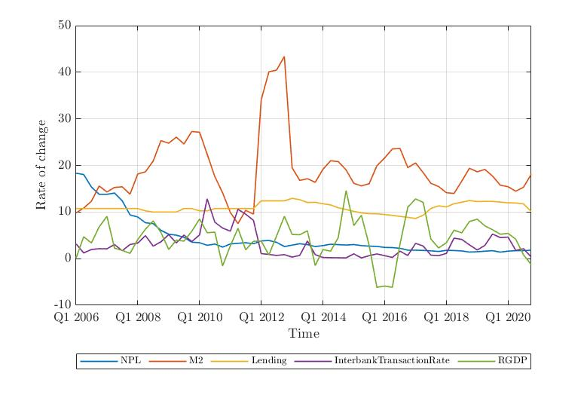

Figure 8 indeed shows the stationary level of the variables with the order of integration I(0). On the x-axis and y-axis, there is time duration and rate of change in variables respectively. All the 5 variables NPL, money supply, interest rate (lending), interbank transaction rate and RGDP are considered to be at level form.

### Selection of Optimal Lag

The next step is to select the lag orders of the variables in VAR model based on the AIC and HQ criteria. The purpose of this analysis, the order of the underlying VAR models were given as one due to the small number of time-series observations available and the large number of endogenous variables and unknown parameters involved to ensure the stability of the VAR (Nkusu, 2011). The optimal lag length helps to provide the best fit model for the analysis such that its implication can be seen in the further analysis part. The selection of the optimal lag length is illustrated in the following table:

**Table 8:** Selection of optimal lag length

|  |  |  |  |  |  |  |
| --- | --- | --- | --- | --- | --- | --- |
| **Lag** | **LogL** | **LR** | **FPE** | **AIC** | **SC** | **HQ** |
| 0 | -642.4933 | NA | 28123.1 | 24.4337 | 24.6195 | 24.5051 |
| 1 | -456.0918 | 330.599 | 63.9802 | 18.3430 | **19.4583\*** | 18.7719 |
| 2 | -441.1872 | 23.6223 | 96.0871 | 18.7240 | 20.7686 | 19.5103 |
| 3 | -441.7408 | 41.1137 | 86.8296 | 18.5562 | 21.5302 | 19.6999 |
| 4 | -369.6093 | 50.8757 | 51.9240 | 17.9097 | 21.8131 | 19.4108 |
| 5 | -325.7863 | 44.6498 | 32.2169 | 17.1994 | 22.0322 | 19.0579 |
| 6 | -280.3747 | **37.7002\*** | 21.9696 | 16.4292 | 22.1914 | 18.6450 |
| 7 | -231.2186 | 31.5340 | **16.6591\*** | **15.5176\*** | 22.2092 | **18.0909\*** |

From the above table the optimal lag length of 7 was chosen based on the available criteria information as shown in above tables respectively. Thus all the variables contain seven endogenous variables and the VAR model includes the total of 35 (5*7) endogenous variables.

### Co-integration Test

The number of cointegrating relationships for the individual VAR models are computed using Johansen trace statistics and maximum eigenvalue at 5 per cent significance level. The result for the co-integration rank test is based on trace and maximum eigenvalues test statistic as outlined in Sheefeni (2015) which are presented in the table 9 and 10 respectively.

**Table 9:** Unrestricted Cointegration Rank Test (Trace)

|  |  |  |  |  |
| --- | --- | --- | --- | --- |
| **Hypothesized No. of CE(s)** | **Eigenvalue** | **Trace Statistic** | **0.05 Critical Value** | **Prob.** |
| None* | 0.7844 | 228.9009 | 69.8188 | 0.0000 |
| At most 1* | 0.3062 | 36.2424 | 29.7970 | 0.0000 |
| At most 2* | 0.6519 | 86.4170 | 29.7970 | 0.0000 |
| At most 3* | 0.3849 | 31.5293 | 15.4947 | 0.0001 |
| At most 4* | 0.1133 | 6.25612 | 3.8414 | 0.0124 |

**Table 10:** Unrestricted Cointegration Rank Test (Maximum Eigenvalue)

|  |  |  |  |  |
| --- | --- | --- | --- | --- |
| **Hypothesized No. of CE(s)** | **Eigenvalue** | **Maximum Eigenvalue Statistic** | **0.05 Critical Value** | **Prob.** |
| None* | 0.7844 | 79.7960 | 33.8768 | 0.0000 |
| At most 1* | 0.3062 | 62.6878 | 27.5843 | 0.0000 |
| At most 2* | 0.6519 | 54.8876 | 21.1316 | 0.0000 |
| At most 3* | 0.3849 | 25.2732 | 14.2646 | 0.0001 |
| At most 4* | 0.1133 | 6.2561 | 3.8414 | 0.0124 |

The Johansen’s trace and maximum eigenvalue test supports the existence of cointegrating relationships and the number of cointegrating vectors which varies from 1 to 4. The result for both trace and maximum eigenvalue shows there is co-integrating equation among all the vectors. Hence, the null hypothesis of no co-integration could not be rejected. Furthermore, this implies that long run analysis can be conducted by estimating a VECM model.

### Granger Causality Test

The Granger-causality statistics examine whether lagged values of one variable help to predict another variable (Stock & Watson, 2001). For example, if the nonperforming loans does not help predict money supply, then the coefficients on the lags of nonperforming loans will all be zero in the reduced-form money supply equation. Table 11 summarizes the Granger-causality result for the five-variable VAR. It shows the p-values associated with the F-statistics for testing whether or not the relevant sets of coefficient are zero.

**Table 11:** Granger causality tests for non-performing loans

|  |  |  |  |  |  |
| --- | --- | --- | --- | --- | --- |
| **Dependent variables in Regression** | **Regressor** | | | | |
| **NPL** | **M2** | **IR** | **IBR** | **RGDP** |
| NPL | 0.00 | **0.0000\*** | **0.0017\*** | **0.0000\*** | **0.0154\*** |
| M2 | 0.7620 | 0.00 | 0.6234 | 0.0453 | 0.6871 |
| IR | 0.9058 | 0.2675 | 0.00 | 0.1617 | 0.1151 |
| IBR | 0.3025 | 0.0338 | 0.1810 | 0.00 | 0.4960 |
| RGDP | 0.5419 | 0.0396 | 0.0019 | 0.7279 | 0.00 |

At the macroeconomic level, money supply, interest rate, real gross domestic product and interbank transaction rate are Granger-causal to nonperforming loans. The result show that there is unidirectional causality in interest rate, inflation rate to non-performing loans. The null hypothesis of no causality rejected at 5 per cent level of significance.

### Serial Correlation Test

In order to test the presence of serial correlation the Breusch-Godfrey test has been used. The presence of serial correlation would draw an incorrect conclusion such that it is required to check whether the variables are serially correlated or not. The following table shows the Breush-Godfrey serial correlation LM test:

**Table 12:** Breusch-Godfrey Serial Correlation LM test

|  |  |  |  |  |  |  |
| --- | --- | --- | --- | --- | --- | --- |
| **Lags** | **LRE stat** | **df** | **Prob.** | **Rao F-stat** | **df** | **Prob.** |
| 1 | 32.7773 | 25 | 0.1367 | 1.4409 | (25, 31.2) | 0.1655 |
| 2 | 36.7234 | 25 | 0.0613 | 1.7012 | (25, 31.2) | 0.0797 |
| 3 | 35.6779 | 25 | 0.0766 | 1.6299 | (25, 31.2) | 0.0976 |
| 4 | 37.4517 | 25 | 0.0522 | 1.7519 | (25, 31.2) | 0.0689 |
| 5 | 18.2111 | 25 | 0.8332 | 0.6638 | (25, 31.2) | 0.8518 |
| 6 | 25.9645 | 25 | 0.4094 | 1.0444 | (25, 31.2) | 0.4491 |
| 7 | 20.8155 | 25 | 0.7028 | 0.7840 | (25, 31.2) | 0.7315 |

Table 12 reports the serial autocorrelation of VAR model where it is observed that there does not exist serial autocorrelation between the variables as the probability value is greater than 0.05 in each lag period. The result of Breusch-Godfrey serial correlation LM test for the residual of the VAR model is conducted by taking upto seven lags. The null hypothesis of no serial correlation cannot be rejected based on the findings which shows that there is no autocorrelation in the VAR model.

### Impulse Response Function

**Figure 9:** Impulse response of banks’ NPL to macroeconomic variables in Nepal

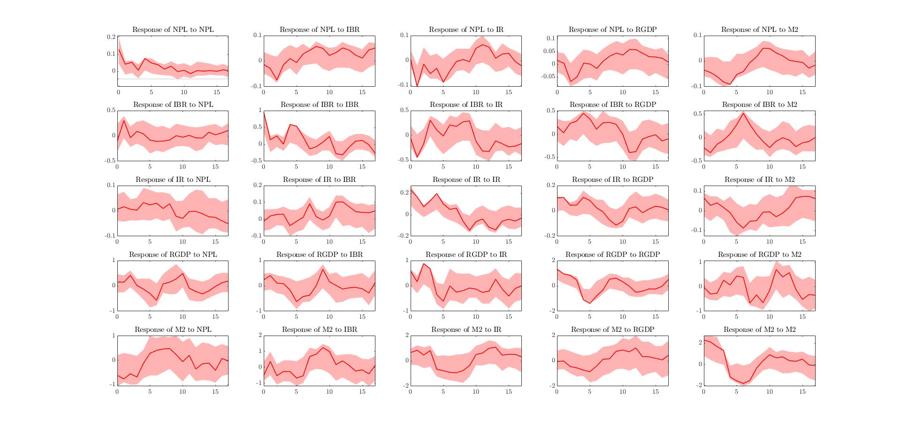

The impulse responses for the recursive VAR, ordered NPL, IBR, IR, RGDP and M2 are plotted in Figure 9. The impulse response is analyzed through Choleski variance decomposition with ±2 standard error. The first row shows the effect of an unexpected 1 percentage point change in NPL would affect the NPL, IBR, IR, RGDP and M2. When there is a positive shock in NPL the response of NPL over the time would decrease as shown in the first figure of the first row. Similarly when there is a positive shock in interbank transaction rate then NPL would increase. The shock in interest rate would create volatile situation to nonperforming loans as can be seen on first row third column. Likewise, when there is a positive shock in economic growth the proportion of non-performing loans would increase at a decreasing rate which is also similar to that with the money supply as it decreases at initial period then increases at an increasing rate then later it declines as shown in first row fifth column.

The impact of a shock to NPLs: An increase in NPLs leads to a prolonged period of reduction in interest rate with repercussions to economic activity. Other things being same, a one percentage point increase in NPLs results in a cumulative decline of 0.10 in the interbank transaction rate and a cumulative increase of nearly 0.2 percentage points in real gross domestic product. Additionally, such a shock leads to a cumulative contraction of 1.67 percentage points in money supply over 18 period.

## Discussion

First to meet the objective of this study the trend analysis have been conducted in section 4.3 where we can observe the trend of non-performing loans, interest rate, interbank transaction rate, real gross domestic product, and money supply. These trend line helps us to understand the current scenario of the variable considered in the study with emphasizing on what makes those curve fluctuating over the period of time. With the help of the trend line it gave more insight on whether the considered variables are in level or at first difference even before conducting the unit root test. From the past studies we have found that these trend analysis were missing and haven’t been conducted but this study have incorporated it.

Secondly, from the analysis conducted by (Fofack, 2005) he found that NPLs are sensitive to bank-level factors and is found to respond to macroeconomic conditions, such as GDP growth, the result also suggests that an increase in NPLs has a significant impact on credit, real GDP growth, money supply, unemployment, real interest rate, interbank transaction and inflation. The result were similar to that of this study where the NPLs is negatively correlated with real GDP growth, money supply, and interbank transaction rate however, interest rate came out to be negatively correlated to NPLs. The granger causality of Fofack showed that there is granger causality between inflation, real interest rate, real GDP growth, nominal interest rate on 1 and 2 number of lags whereas, in this study NPLs is granger causal with interbank transaction rate, real GDP growth, money supply, and interest rate which also gives meaningful result for the further analysis.

Lastly to answer if the banks really do absorb the shocks? The impulse response function have been performed where we can see that if there is a one percent change in independent variable would bring the change in the NPLs. In similar fashion, how one percent change in NPL would impact the independent variables is illustrated. Similar impulse response has been carried out in Klein (2013), where he showed that increase in one percentage point in real GDP leads to a decline of 0.8 percentage point in NPLs likewise in this study it found that there is a decline of 0.2 percentage point in NPLs.

# CHAPTER V: SUMMARY AND CONCLUSIONS

## Introduction

This concluding chapter highlights the major empirical findings, conclusions and recommend to those future aspirant researcher about the non-performing loans and the use of VAR model based on the evidence from literature and empirical analysis. Section 5.2 provides summary of the major findings of the study, followed by section 5.3 which offer concluding remark and section 5.4 presents’ recommendations and provide important points for future study.

## Summary

The non-performing loans is affected by many factors which this study has tried to uncover some of it. The major objective of this thesis is to analyze the macroeconomic determinants of the non-performing loans in Nepal. The objective of this thesis has outlined in the chapter 1 where analyzing the trend of the variables, how the macroeconomic determinant has affects the NPL and confirm to provide the detailed insight into determinant that affect the non-performing loans of commercial banks in Nepal.

This thesis is based on the secondary time series data covering from 2006:Q1 to 2020 Q2 with 60 observation and 5 macroeconomic variables. The data for the variables are collected from the NRB, Ministry of Finance, and CBS. This study hypothesize that the non-performing loans has a negative relationship with economic growth, as when there is a slowdown in the economy the level of NPLs is likely to increase as unemployment rises and the borrowers face difficulties to repay their debt. Other macroeconomic variables which were found to affect the banks’ asset quality includes the interest rate, interbank transaction rate and money supply. In this regards all the variables have a negative impact on non-performing loans, particularly in a country like Nepal where there is high debt. MATLAB software was used to analyze the secondary data which includes descriptive statistics, correlation analysis, and selection of optimal lag, serial correlation test, co-integration test, granger causality and impulse response. Based on the data analysis the following are the major findings of this study:

Interest rate negatively influence the NPL rate, when there is a one percentage point increase in interest rate would results into decline of 0.12 times in NPLs. Similarly, money supply, interbank transaction rate and real gross domestic product all would result into decline in NPLs by 0.234, 0.034, and 0.06 times respectively.

The unit root test enables to understand if the variables are in the level or in the first difference form. In order to run the VAR model it requires that all the variables are in the level form any transformation in the variable will gives spurious result. Thus the ADF test and PP test of unit root provides us that all the variables are in level form.

The result from the unit root test enables to proceed with VAR model, then the next step is to select the optimal lag length. For this study the 7 lag length have been selected. After running through 7 lag length on VAR model firstly the diagnostic test has been performed where it can be observed that there is no serial correlation between the variables. The co-integration test reports that the null hypothesis of no co-integration could not be rejected such that long run analysis must be conducted by estimating a VECM. Likewise, the granger causality test shows that there is unidirectional causality between non-performing loans and interest rate, interbank transaction rate, money supply and real gross domestic product. The impulse response function is conducted through Choleski variance decomposition which shows the response of NPL to other variables, and impact of a shock to NPLs.

## Conclusion

The primary aim of the thesis was to demonstrate that NPLs of Nepalese commercial banks’ are affected by the macroeconomic conditions of the country. The results have shown that the NPLs are affected by macroeconomic conditions of the country and highlight the interlinkages that exists between the asset quality of banks and macroeconomic condition along with interbank transaction rate. The result from this study provide evidence that supports the previous literature where the NPLs are affected by the macroeconomic variables as well as bank specific variables such as interest rate, interbank transaction rate, money supply, and real gross domestic product.

A granger-causality analysis identifies interest rate, interbank transaction rate, money supply, and real gross domestic product as other possible determinants. The granger-causality results are further corroborated with a dynamic approach which highlights the macroeconomic volatility in explaining the proportional variance of these sort of loans. In short run the banks face liquidity problems resorted to short term financing in the form of interbank loans, however the high cost of these loans further exacerbate the non-performing loans.

Nevertheless, the result of the test conducted in the previous section have justified that the hypothesis created in the first chapter. There is a negative relationship between the interest rate and the non-performing loans, similarly the economic growth of Nepal would result in the fall of NPL rate. As the money supply decreases in the economy the NPL rate increases in similar way the decreasing interbank transaction rate would result into increase in NPL rate.

The VAR model contribute to analyze the dynamic relationship between the variables considered in the studies. This study suggests that the Nepalese banking sector has attained a considerable ability to withstand a credit risk shock and the banking sector stability is compatible with both the economic growth and interest rate. From the analysis part it is recommended that in order to use the VAR model all the variables must be in level form and the variable considered for the study must have causal relationship with the dependent variable and the long run relationship can be shown through its extension model.

# REFERENCES

Adebola, S., Yusoff, W., & Dahalan, J. (2011). An ARDL approach to the determinants of non-performing loans in Islamic banking system in Malaysia. *Kuwait Chapter of Arabian Journal of Business and Management* .

Agiropoulos, C., Galanos, G., & Poufinas, T. (2021). Debt Versus Non-Performing Loans: An Investigation on the Causality Direction Within the Countries of Eurozone. *Springer*, 215-235.

Ahmad , F., & Bashir, T. (2013). Explanatory Power of Macroeconomic Variables as Determinants of Non-Performing Loans: Evidence form Pakistan. *World Applied Sciences Journal*, 22 (2): 243-255.

Babouček, I., & Jančar, M. (2005). *A VAR analysis of the effects to macroeconomic shocks to the quality of the aggregate loan portfolio of the Czech banking sector.* Czech National Bank.

Badar, M., & Javid, A. ( 2013). Impact of Macroeconomic Forces on Non-performing Loans: An Empirical Study of Commercial Banks in Pakistan. *WSEAS TRANSACTIONS on BUSINESS and ECONOMICS*, 1(10): 40-48.

Berger, A., & DeYoung, R. (1997). Problem Loans and Cost Efficiency in Commercial Banks. *Journal of Banking and Finance*, 849–870.

Bernanke , B., & Gertler, M. (1995). Inside the Black Box: The Credit Channel of Monetary Policy Transmission. *Journal of Economic Perspectives*, 9, 27-48.

Bhattarai, S. (2015). Determinants of Non-Performing Loan in Nepalese Commercial Banks. *Economic Journal of Development Issues*.

Bholat, D., Lastra, R., Markose, S., Miglionico, A., & Sen, K. (2016). *Non-performing loans: regulatory and accounting treatments of assets.* Bank of England.

Bjørnland, H. C. (2000). *VAR Models in Macroeconomic Research.* Statistics Norway Research Department.

Butt , N., Domit , S., McLeay, M., Thomas , R., & Kirkham, L. (2012). What can the money data tell us about the impact of QE? *Bank of England Quarterly Bulletin*.

CBS. (2020). *Quarterly GDP.* Kathmandu: Central Bureau of Statistic.

Christiano, L., Motto , R., & Rostagno, M. (2010). Financial Factors in Economic Fluctuations. *European Central Bank Working Paper Series*.

Espinoza, R., & Prasad, A. (2010). *Nonperforming loans in the GCC banking system and their macroeconomic effects.* IMF Working Paper no. 10/224, October.

European Bank Coordination Vienna Initiative. (2014, September 26). *The Vienna Initiative pushes for action plan to deal with NPLs in central and south-eastern Europe*. Retrieved from http://vienna-initiative.com/npl-initiative/news-on-the-initiative/

Festic, M. K. (2011). The macroeconomic sources of systemic risk in the banking sectors of five new EU member states. *Journal of Banking and Finance*, 35: 310-322.

Fofack, H. (2005). Nonperforming Loans In Sub-Saharan Africa: Causal Analaysis and Macroeconomic Implications. *World Bank Policy Research Working Paper 3769*.

Geletta, W. ( 2012). *Determinants of Non-performing Loans: The Case of Ethiopian Banks.* Unpublished Master’s Thesis, University of South Africa.

Granger, C. (1969). Investigating Causal Relations by Econometric Models and Crossspectral Methods. *Econometrica*, 37(3): 424-438.

Hasan, Z. (2019 ). Macroeconomic Determinants of Non-Performing Loans in Bangladesh: An ARDL Approach . *Scientific Research Journal*.

Hoggarth, G., Sorensen, S., & Zicchino, L. (2005). *Stress tests of UK banks using a VAR approach.* Bank of England Working Paper no. 282, November.

International Monetary Fund. (2011). *Nepal: Selected Issues.* Washington, D.C: International Monetary Fund.

Ito, T., & Sato, K. (2008). Exchange Rate Changes and Inflation in Post-Crisis Asian Economies: Vector Autoregression Analysis of the Exchange Rate Pass-Through. *Journal of Money, Credit and Banking*, 1407-1438.

Jimenez, G., & Saurina, J. (2005). Credit cycles, credit risk, and prudential regulation. *Banco de Espana*.

Khemraj , T., & Pasha , S. (2009). The determinants of non-performing loans: an econometric case study of Guyana. *Munich Personal RePEc Archive*.

Kjosevski, J. (2017). Non-performing loans in Baltic States: determinants and macroeconomic effects. *Baltic Journal of Economics*.

Klein, N. (2013). *Non-Performing Loans in CESEE: Determinants and Macroeconomic Performance .* IMF Working Paper .

Marcucci, J., & Quagliariello, M. (2006). Is bank portfolio riskiness procyclical? Evidence from Italy using a vector autoregression. *Journal of International Financial Markets, Institution & Money*.

Maskay, N., & Pandit, R. (2009). *Interest Rate Pass-Through in Nepal.* Nepal Rastra Bank.

Ministry of Finance. (2020/21). *Economic Survey.* Kathmandu: MoF.

MoF. (2020). *Economic Survey.* Kathmandu: Ministry of Finance.

Nakagawa, S., & Oshima, K. (2000). Does a Decrease in the Real Interest Rate Actually Stimulate Personal Consumption? *Bank of Japan*.

Neupane, S. (2019). Examining Volatility of Interbank Rate in Nepal. *NRB Economic Review*.

Nkusu, M. (2011). *Nonperforming loans and macrofinancial vulnerabilities in advanced economies.* IMF Working Paper no. 11/161, July.

NRB. (2020). *Banking & Financial Institution Monthly Statistics.* Kathmandu: Nepal Rastra Bank.

NRB. (2020). *Key Financial Indicator.* Nepal Rastra Bank.

NRB. (2020). *Quarterly Bank and Financial Institution Statistic.* Nepal Rastra Bank.

NRB. (2020). *Quarterly Economic Bulletin.* Nepal Rastra Bank.

NRB. (2021). *Monetary Policy.* Nepal Rastra Bank.

Ozaki, M. (2014). *Finance Sector Reform in Nepal—What Works, What Doesn’t.* ADB South Asia Working Paper Series .

Prasanna, K. P. (2014). Determinants of Non-Performing Loans in Indian Banking System. *3rd International Conference on Management.* Behavioral Sciences and Economics Issues. Singapore.

Rachel , L., & Smith , T. D. (2015). Secular drivers of the global real interest rate. *Bank of England Staff Working Paper No.571*.

Rajan, R., & Dahl, S. (2003). “Non-performing Loans and Terms of Credit of Public Sector Banks in India: An Empirical Assessment. *Reserve Bank of India Occasional Papers*.

Roman , A., & Bilan, I. (2015). An empirical analysis of the macroeconomic determinant of non-performing loans in EU28 Banking sector. *Revista Economică*.

Salas , V., & Saurina, J. (2002). Credit Risk in Two Institutional Regimes: Spanish Commercial and Savings Banks. *Journal of Financial Services Research*, 203–224.

Schinasi, J. (2005). *Preserving financial stability.* Washington: International Monetary Fund.

Shan, J. (2005). *Does financial development ‘lead' economic growth? A vector auto-regression appraisal.* London: Routledge.

Sheefeni, J. P. (2015). The Impact of Macroeconomic Determinants on Non-performing Loans in Namibia. *An Online International Research Journal*.

Sidemark, T. (2014). *The macroeconomic determinants of banks’ nonperforming loans in Europe: a GVAR approach.* STOCKHOLM SCHOOL OF ECONOMICS.

Sims, C. (1986). Are Forecasting Models Usable for Policy Analysis? *Federal Reserve Bank of Minneapolis Quarterly Review*, 10, 2-16.

Siraj, K., & Sudarsanan, P. (2013). A Study on the Performance of Non-Performing Assets (NPAs) of Indian Banking during Post Millennium Period. *International journal for business and management*.

Steffensmeier, J. M., Freeman, J. R., Hitt, M. P., & Pevehouse, J. C. (2014). *Time Series Analysis for the Social Sciences.* Cambridge University Press.

Stock, J. H., & Watson, M. W. (2001). Vector Autoregressions. *Journal of Economic Perspectives*, Pages 101-115.

# APPENDIX

**APPENDIX-1: Data set used for the study**

|  |  |  |  |  |  |
| --- | --- | --- | --- | --- | --- |
| **Year** | **Non-Performing loans to total gross loan (%)** | **Money Supply (M2) (%)** | **RGDP (%)** | **Interest Rate (%)** | **Interbank Transaction Rate (%)** |
| 2006Q1 | 18.3 | 9.8 | 0.1 | 10.75 | 3.18 |
| 2006Q2 | 18.0 | 10.9 | 4.7 | 10.75 | 1.22 |
| 2006Q3 | 15.4 | 12.3 | 3.4 | 10.75 | 1.97 |
| 2006Q4 | 13.8 | 15.6 | 6.8 | 10.75 | 2.13 |
| 2007Q1 | 13.8 | 14.3 | 9.1 | 10.75 | 2.11 |
| 2007Q2 | 14.1 | 15.3 | 2.2 | 10.75 | 3.03 |
| 2007Q3 | 12.4 | 15.4 | 1.8 | 10.75 | 1.69 |
| 2007Q4 | 9.4 | 13.8 | 1.1 | 10.75 | 3.03 |
| 2008Q1 | 8.9 | 18.2 | 4.1 | 10.75 | 3.35 |
| 2008Q2 | 7.7 | 18.6 | 6.3 | 10.25 | 4.93 |
| 2008Q3 | 7.5 | 20.9 | 8.1 | 10.00 | 2.69 |
| 2008Q4 | 6.1 | 25.3 | 5.6 | 10.00 | 3.61 |
| 2009Q1 | 5.2 | 24.8 | 2.0 | 10.00 | 5.16 |
| 2009Q2 | 5.0 | 26.1 | 4.0 | 10.00 | 3.37 |
| 2009Q3 | 4.6 | 24.6 | 3.8 | 10.75 | 5.06 |
| 2009Q4 | 3.5 | 27.3 | 5.9 | 10.75 | 3.66 |
| 2010Q1 | 3.4 | 27.1 | 8.5 | 10.25 | 5.1 |
| 2010Q2 | 2.9 | 22.4 | 5.6 | 10.25 | 12.83 |
| 2010Q3 | 3.1 | 17.6 | 5.7 | 10.75 | 7.81 |
| 2010Q4 | 2.5 | 14.1 | -1.6 | 10.75 | 6.57 |
| 2011Q1 | 3.2 | 9.9 | 2.8 | 10.75 | 5.89 |
| 2011Q2 | 3.3 | 7.5 | 6.5 | 10.75 | 10.58 |
| 2011Q3 | 3.4 | 10.4 | 1.9 | 10.75 | 9.54 |
| 2011Q4 | 3.2 | 9.5 | 3.7 | 10.75 | 8.22 |
| 2012Q1 | 3.8 | 34.1 | 3.8 | 12.40 | 1.08 |
| 2012Q2 | 3.9 | 40.1 | 0.8 | 12.40 | 0.9 |
| 2012Q3 | 3.5 | 40.5 | 4.9 | 12.40 | 0.69 |
| 2012Q4 | 2.6 | 43.4 | 9.1 | 12.40 | 0.86 |
| 2013Q1 | 2.9 | 19.5 | 5.2 | 12.94 | 0.33 |
| 2013Q2 | 3.2 | 16.8 | 5.1 | 12.65 | 0.71 |
| 2013Q3 | 3.0 | 17.2 | 6.0 | 12.05 | 3.78 |
| 2013Q4 | 2.6 | 16.4 | -1.5 | 12.09 | 0.86 |
| 2014Q1 | 2.8 | 19.2 | 1.9 | 11.78 | 0.25 |
| 2014Q2 | 3.1 | 21.0 | 1.6 | 11.53 | 0.21 |
| 2014Q3 | 3.0 | 20.8 | 4.5 | 10.92 | 0.19 |
| 2014Q4 | 2.9 | 19.1 | 14.6 | 10.55 | 0.16 |
| 2015Q1 | 3.0 | 16.2 | 7.1 | 10.14 | 1.03 |
| 2015Q2 | 2.8 | 15.6 | 9.3 | 9.82 | 0.15 |
| 2015Q3 | 2.7 | 16.1 | 2.9 | 9.64 | 0.64 |
| 2015Q4 | 2.6 | 19.9 | -6.2 | 9.62 | 1.01 |
| 2016Q1 | 2.4 | 21.6 | -5.9 | 9.46 | 0.64 |
| 2016Q2 | 2.4 | 23.5 | -6.2 | 9.29 | 0.26 |
| 2016Q3 | 2.2 | 23.6 | 3.1 | 9.06 | 1.59 |
| 2016Q4 | 1.8 | 19.5 | 11.0 | 8.86 | 0.69 |
| 2017Q1 | 1.8 | 20.5 | 12.8 | 8.62 | 3.27 |
| 2017Q2 | 1.8 | 18.5 | 12.1 | 9.31 | 2.71 |
| 2017Q3 | 1.7 | 16.2 | 4.2 | 10.77 | 0.75 |
| 2017Q4 | 1.5 | 15.5 | 2.3 | 11.33 | 0.64 |
| 2018Q1 | 1.8 | 14.2 | 3.4 | 11.1 | 1.13 |
| 2018Q2 | 1.7 | 14.0 | 6.1 | 11.79 | 4.4 |
| 2018Q3 | 1.7 | 16.6 | 5.5 | 12.1 | 4.12 |
| 2018Q4 | 1.4 | 19.4 | 8.0 | 12.47 | 2.96 |
| 2019Q1 | 1.5 | 18.6 | 8.5 | 12.26 | 1.86 |
| 2019Q2 | 1.6 | 19.1 | 7.0 | 12.29 | 2.84 |
| 2019Q3 | 1.7 | 17.7 | 6.2 | 12.28 | 5.28 |
| 2019Q4 | 1.4 | 15.8 | 5.2 | 12.13 | 4.52 |
| 2020Q1 | 1.6 | 15.4 | 5.4 | 11.98 | 4.62 |
| 2020Q2 | 1.7 | 14.5 | 4.2 | 11.94 | 1.76 |
| 2020Q3 | 1.7 | 15.3 | 0.8 | 11.77 | 2.13 |
| 2020Q4 | 1.8 | 18.1 | -1.28 | 10.11 | 0.35 |

MATLAB Command Window

December 18, 2021

Page 1

2:59:08 PM

>> ans= datenum (Year,'QQ yyyy')

>> plot(ans,NPL,'DisplayName','NPL');hold on;plot(ans,RGDP,'DisplayName','RGDP');hold off;

>> datetick ('x','QQ yyyy')

>> grid on

>> plot(NPL,M2,'DisplayName','M2');hold on;plot(NPL,Lending,'DisplayName','Lending'); plot(NPL,InterbankTransactionRate,'DisplayName','InterbankTransactionRate');plot(NPL, RGDP,'DisplayName','RGDP');hold off;

>> plot(ans,'DisplayName','ans');hold

on;plot(NPL,'DisplayName','NPL');plot (M2,'DisplayName','M2');plot(Lending,'DisplayName','Lending';

plot(InterbankTransactionRate,'DisplayName','InterbankTransactionRate');plot (RGDP,'DisplayName','RGDP');hold off;

>> plot(ans,NPL,'DisplayName','NPL');hold on;plot(ans,M2,'DisplayName','M2'); plot (ans,Lending,'DisplayName','Lending');plot(ans, InterbankTransactionRate,'DisplayName','InterbankTransactionRate');plot(ans, RGDP,'DisplayName','RGDP');hold off;

>> grid on

>> datetick('x','QQ yyyy')

>> plot(ans,NPL,'DisplayName','NPL');hold on;plot(ans,M2,'DisplayName','M2'); plot ans,Lending,'DisplayName','Lending');plot(ans, InterbankTransactionRate,'DisplayName','InterbankTransactionRate');plot(ans, RGDP,'DisplayName','RGDP');hold off;

>> grid on

>> datetick('x','QQ yyyy')

>> Md1=varm(5,7)

>> Md1=estimate(Md1,BanklendingS5)

Md1 = varm with properties:

Description: "AR-Stationary 5-Dimensional VAR(7)

Model" SeriesNames: "Y1" "Y2" "Y3" ... and 2 more

NumSeries: 5

P: 7

Constant: [1.6728 7.60907 4.22037 ... and 2 more]'

AR: {5×5 matrices} at lags [1 2 3 ... and 4 more]

Trend: [5×1 vector of zeros]

Beta: [5×0 matrix]

Covariance: [5×5 matrix]

>> [Response, lower, upper] = irf(Md1, 'method','generalized')

>> subplot (5,5,1)

>> confplot(IRFS4,IRFS2,IRFS1,IRFS3,'color',[1 0 0],'linewidth',1);

>> subplot (5,5,2)

>> confplot(IRFS4,IRFS6,IRFS5,IRFS7,'color',[1 0 0],'linewidth',1);

>> subplot (5,5,3)

>> confplot(IRFS4,IRFS9,IRFS8,IRFS10,'color',[1 0 0],'linewidth',1);

>> subplot (5,5,4)

MATLAB Command Window

December 18, 2021

>> confplot(IRFS4,IRFS12,IRFS11,IRFS13, 'color',[100],'linewidth',1);

>> subplot (5,5,5)

>> confplot(IRFS4,IRFS15,IRFS14,IRFS16, 'color',[100],'linewidth',1);

>> subplot (5,5,6)

>> confplot(IRFS4,IBR2,IBR1,IBR3,'color',[1 0 0],'linewidth',1);

>> Subplot (5,5,7)

>> confplot(IRFS4,IBR5,IBR4,IBR6,'color',[1 0 0],'linewidth',1);

>> subplot (5,5,8)

>> confplot(IRFS4,IBR8,IBR7,IBR9,'color',[1 0 0],'linewidth',1);

>> subplot (5,5,9)

>> confplot(IRFS4,IBR11,IBR10,IBR12,'color',[1 0 0],'linewidth',1);

>> subplot (5,5,10)

>> confplot(IRFS4,IBR14,IBR13,IBR15,'color',[1 0 0],'linewidth',1);

>> subplot (5,5,11)

>> confplot(IRFS4,IR2,IR1,IR3,'color',[1 0 0],'linewidth',1);

>> subplot (5,5,12)

>> confplot(IRFS4,IR5,IR4,IR6,'color',[1 0 0],'linewidth',1);

>> subplot (5,5,13)

>> confplot(IRFS4,IR8,IR7,IR9,'color',[1 0 0],'linewidth',1);

>> subplot (5,5,14)

>> confplot(IRFS4,IR11,IR10,IR12,'color',[1 0 0],'linewidth',1);

>> subplot (5,5,15)

>> confplot(IRFS4,IR14,IR13,IR15,'color',[1 0 0],'linewidth',1);

>> subplot (5,5,16)

>> confplot(IRFS4,GDP2,GDP1,GDP3,'color',[1 0 0],'linewidth',1);

>> subplot (5,5,17)

>> confplot(IRFS4,GDP5,GDP4,GDP6,'color',[1 0 0],'linewidth',1);

>> subplot (5,5,18)

>> confplot(IRFS4,GDP11,GDP10,GDP12,'color',[1 0 0],'linewidth',1);

>> subplot (5,5,19)

>> confplot(IRFS4,GDP8,GDP7,GDP9,'color',[1 0 0],'linewidth',1);

>> subplot (5,5,20)

>> confplot(IRFS4,GDP14,GDP13,GDP15,'color',[1 0 0],'linewidth',1);

>> subplot (5,5,21)

>> confplot(IRFS4,MS2,MS1,MS3,'color',[1 0 0],'linewidth',1);

>> subplot (5,5,22)

>> confplot(IRFS4,MS5,MS4,MS6,'color',[1 0 0],'linewidth',1);

>> subplot (5,5,23)

>> confplot(IRFS4,MS8,MS7,MS9,'color',[1 0 0],'linewidth',1);

>> subplot (5,5,24)

>> confplot(IRFS4,MS11,MS10,MS12,'color',[1 0 0],'linewidth',1);

Page 2

2:59:08 PM

>> subplot (5,5,25)

>> confplot(IRFS4,MS14,MS13,MS15,'color',[1 0 0],'linewidth',1);

1. The vector autoregression model (VAR) is an n-equation, n-variable linear model in which each variable is in turn explained by its own lagged values, plus current and past values of the remaining n-1 variable (Stock & Watson, 2001). It is the generalization of Autoregression model and is consist of a system of linear equations of the k series being modeled.
2. As financial risk are interlinked around the globe the GVAR method is used as a model to examine the cross-country analysis of non-performing loans.